YEAR 11 HOMEWORK – 1R
BOOKLET 2

Complete the questions in each box. Make sure that you show all of your workings

Ken buys some fruit.  He buys apples, bananas, peaches and oranges.  Ken buys  4 apples weighing 125 g each  2 bananas weighing 170 g each  3 peaches weighing 135 g each  Each orange has a weight of 90 g.  The fruit has a total weight of 1.785 kg.  Work out how many oranges Ken buys | 60 students were asked how they get to school.  The table shows the results.  Bus Walk Car Bicycle  Number of students 15 27 12 6  Complete a pie chart for the information in the table.
Here is a map of an island. Work out the distance between the 2 villages  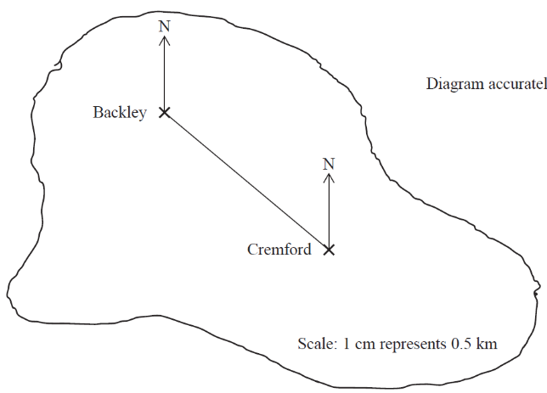  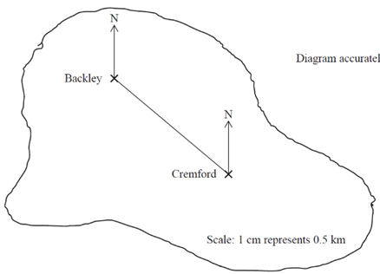 | .  A cinema ticket costs £x The price of a child’s ticket is half the price of an adult ticket. Write an expression for the price, in pounds, of a child’s ticket
Find the input if the output is 32  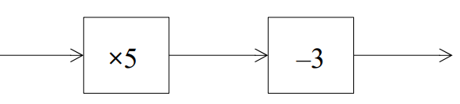 | Find the bearing of A from B  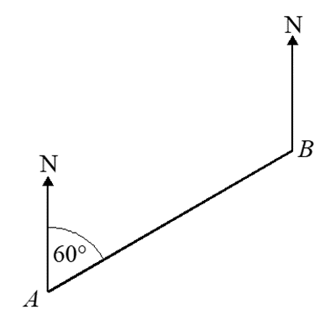
Triangle A is congruent to which other shape? Give reasons | Expand and simplify  (x + 2)(X + 3)
Factorise x² + 10x + 16 | Simplify m³ × m⁴
Find the lowest common multiple (LCM) of 40 and 56 | A = 2³ × 3 × 5 B = 2² × 3 × 5²  Write down the highest common factor (HCF) of A and B.
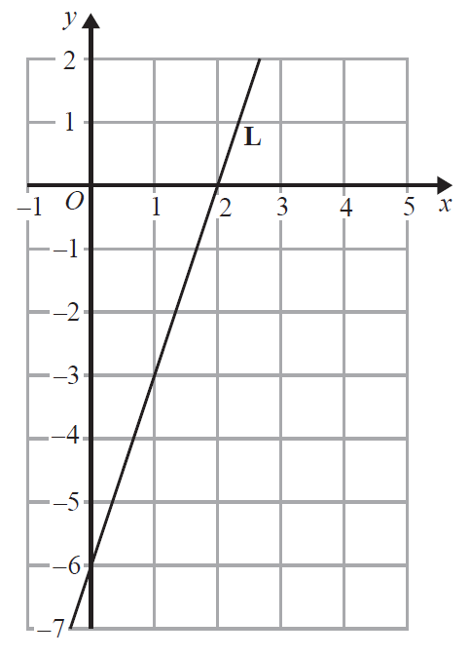  Write the equation of the line: | Raya buys a van for £8500 plus VAT at 20%  Raya pays a deposit for the van.  She then pays the rest of the cost in 12 equal payments of £531.25 each month.  Find the ratio of the deposit Raya pays to the total of the 12 equal payments.  Give your answer in its simplest form.
A force of 70 newtons acts on an area of 20 cm2  The force is increased by 10 newtons.  The area is increased by 10 cm2  Helen says,  “The pressure decreases by less than 20%”  Is Helen correct?  You must show how you get your answer. | 60 people were asked if they prefer to go on holiday in Britain or in Spain or in Italy.  38 of the people were male.  11 of the 32 people who said Britain were female.  8 males said Italy.  12 people said Spain.  One of the females is chosen at random.  What is the probability that this female said Spain?

Jean invests £12 000 in an account paying 2% compound interest for 3 years. Calculate how much interest she has earned at the end of the 3 years. | Solve 2x – 5 > 8
Adam has some marbles. Bradley has twice as many marbles are Adam. Chris has 5 more marbles than Bradley. In total they have 55 marbles. How many marbles does Chris have? | m = 5n + 2p Make p the subject of the formula

WWW
EBI

EBI

