YEAR 11 HOMEWORK – 1S
BOOKLET 2

Complete the questions in each box. Make sure that you show all of your workings

Write $\frac{7}{100}$as a decimal. | Write down a multiple of 6 that is between 40 and 50
Simplify 3f X 3g | Ken buys some fruit. He buys apples, bananas, peaches and oranges.  Ken buys  4 apples weighing 125 g each  2 bananas weighing 170 g each  3 peaches weighing 135 g each  Each orange has a weight of 90 g. The fruit has a total weight of 1.785 kg.  Work out how many oranges Ken buys.
60 students were asked how they get to school.  The table shows the results.  Bus Walk Car Bicycle  Number of students 15 27 12 6  Complete a pie chart for the information in the table. | Annie and Lily share some money in the ratio 4 : 3  What fraction of the money does Lily get?
Steve says,  “There are more prime numbers between 20 and 30  than there are between 10 and 20”  Is Steve right?  You must show how you get your answer. | Chrissy drew this graph to show the percentage of buses that got to a bus stop on time  for six months.  Write down one thing that is wrong with the graph  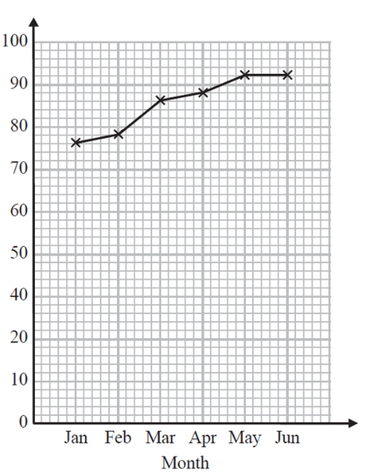  % of buses on time
Here is a map of an island. Work out the distance between the 2 villages  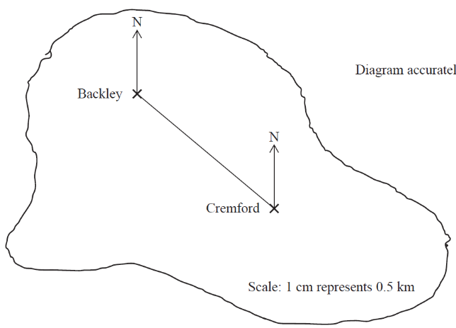 | 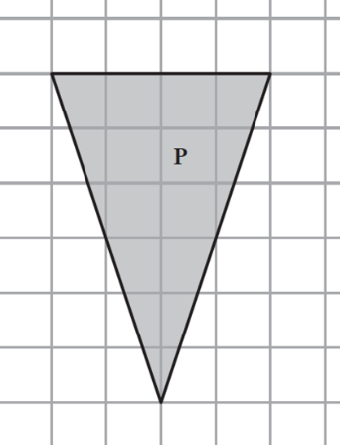  Find the area of the shape
Write the mathematical name of the shape  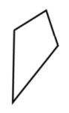 | Simplify k + k + 8
A cinema ticket costs £x The price of a child’s ticket is half the price of an adult ticket. Write an expression for the price, in pounds, of a child’s ticket | 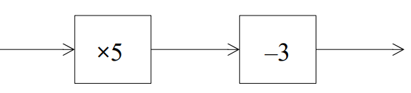  Find the output if the input is 7
What goes in the gap?  4 + ____ = 15 | Solve x + 6 = 18

Find the bearing of A from B  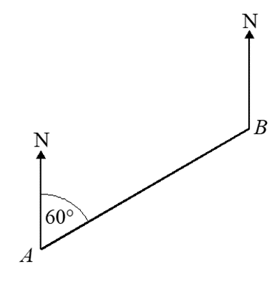 | Triangle A is congruent to which other shape?
Expand and simplify  (x + 2)(x + 3) | Factorise x² + 10x + 16

WWW

EBI

EBI

