YEAR 11 HOMEWORK – 2R
BOOKLET 2

Complete the questions in each box. Make sure that you show all of your workings

1. Ken buys some fruit.  He buys apples, bananas, peaches and oranges.  Ken buys  4 apples weighing 125 g each  2 bananas weighing 170 g each  3 peaches weighing 135 g each  Each orange has a weight of 90 g.  The fruit has a total weight of 1.605 kg.  Work out how many oranges Ken buys | 2. 60 students were asked how they get to school.  The table shows the results.  Bus Walk Car Bicycle  Number of students 17 24 11 8  Complete a pie chart for the information in the table.
3. Here is a map of an island. Work out the distance between the 2 villages  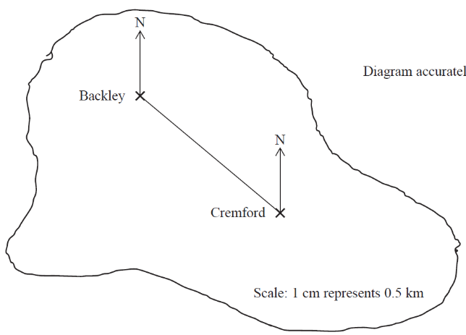  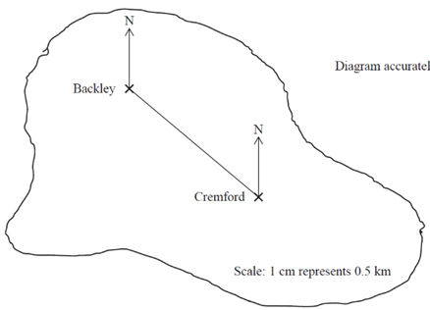  2cm = 5km | 4. A cinema ticket costs £2x The price of a child’s ticket is one third the price of an adult ticket. Write an expression for the price, in pounds, of a child’s ticket
5. Find the input if the output is 32  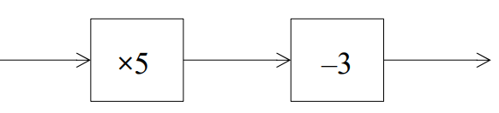  -3  X5 | 6. Find the bearing of A from B  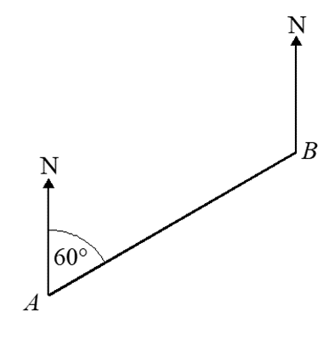  72º
7. Triangle C is congruent to which other shape? Give reasons | 8. Expand and simplify  (x - 2)(x + 8)
9. Factorise x² - 2x - 10 | 10. Simplify m² × m⁵
11. Find the lowest common multiple (LCM) of 18 ,29 and 21 | 12. 648 = 2³ × 3⁴ 540 = 2² × 3³ × 5  Write down the highest common factor (HCF) of 648 and 540.
13. Write the gradient of the line:  y = 4x + 7 | 14. Raya buys a van for £8200 plus VAT at 20%  Raya pays a deposit for the van.  She then pays the rest of the cost in 12 equal payments of £525.20 each month.  Find the deposit amount
15. A force of 60 newtons acts on an area of 15 cm²  The force is increased by 10 newtons.  The area is increased by 10 cm²  Calculate the change in the pressure | 16. 60 people were asked if they prefer to go on holiday in Britain or in Spain or in Italy.  38 of the people were male.  11 of the 32 people who said Britain were female.  8 males said Italy.  12 people said Spain.  One of the females is chosen at random.  What is the probability that this female said Spain?

17. Jean invests £12 000 in an account paying 3% compound interest for 3 years. Calculate how much interest she has earned at the end of the 3 years. | 18. Solve 2x – 7 < 8
19. Adam has some marbles. Bradley has twice as many marbles as Adam. Chris has 10 more marbles than Bradley. In total they have 40 marbles. How many marbles does Chris have? | 20. m = 3n - 2p Make p the subject of the formula

WWW

EBI

EBI

