YEAR 11 HOMEWORK – 2S
BOOKLET 2

Complete the questions in each box. Make sure that you show all of your workings

1. Write $\frac{7}{10}$as a decimal. | 2. Write down a multiple of 7 that is between 30 and 40
3. Simplify 7f X 5g | 4. Ken buys some fruit. He buys apples, bananas, peaches and oranges.  Ken buys  4 apples weighing 120 g each  2 bananas weighing 140 g each  3 peaches weighing 110 g each  Each orange has a weight of 90 g. The fruit has a total weight of 1.45 kg.  Work out how many oranges Ken buys.
5. 60 students were asked how they get to school.  The table shows the results.  Bus Walk Car Bicycle  Number of students 10 25 15 10  Complete a pie chart for the information in the table. | 6. Annie and Lily share some money in the ratio 5 : 2  What fraction of the money does Lily get?
7. Steve says,  “There are more prime numbers between 20 and 30  than there are between 30 and 40”  Is Steve right?  You must show how you get your answer. | 8. Chrissy drew this graph to show the percentage of buses that got to a bus stop on time  for six months.  Write down one thing that is wrong with the graph  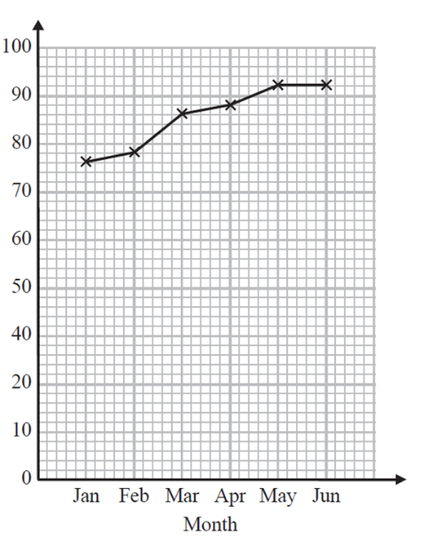  90  80  70  60  50  % of buses on time  40  30
9. Here is a map of an island. Work out the distance between the 2 villages  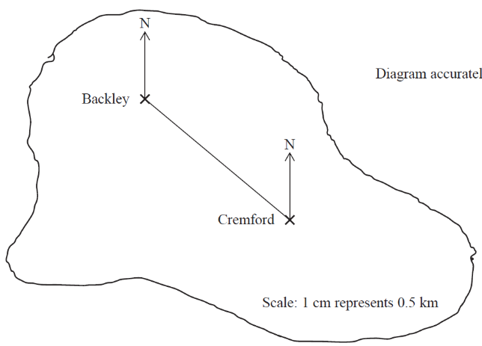  1cm represents 2km | 10. Find the area of the shape  3.5cm  2.5cm  3cm  4cm
11. Write the mathematical name of the shape | 12. Simplify k + k + p
13. A cinema ticket costs £x The price of a child’s ticket is one third the price of an adult ticket. Write an expression for the price, in pounds, of a child’s ticket | 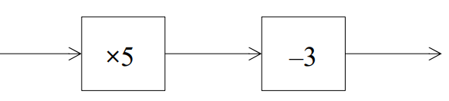  14. Find the output if the input is  +2  -7
15. What goes in the gap?  18 + ____ = 33 | 16. Solve 2x + 6 = 18

17. Find the bearing of A from B  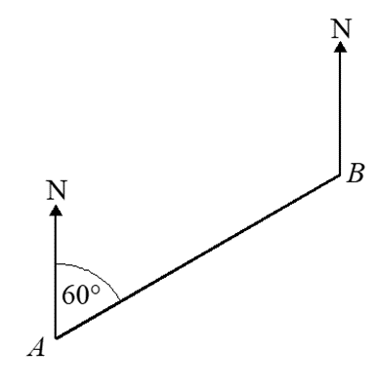  57º | 18. Triangle C is congruent to which other shape?
19. Expand and simplify  (x + 3)(x + 5) | 20. Factorise x² + 9x - 10

