YEAR 11 HOMEWORK – 4R
BOOKLET 2

Complete the questions in each box. Make sure that you show all of your workings

1. The weight of a bag of potatoes is 15 kg, correct to the nearest kg.  (a) Write down the smallest possible weight of the bag of potatoes.  (b) Write down the largest possible weight of the bag of potatoes | 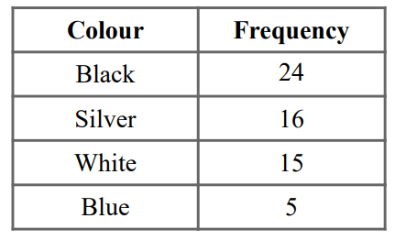  2. Draw a pie chart:
3. A model car has the length of 8cm.  The scale of the model is 1:50  Work out the length of the real car. Give your answer in metres.  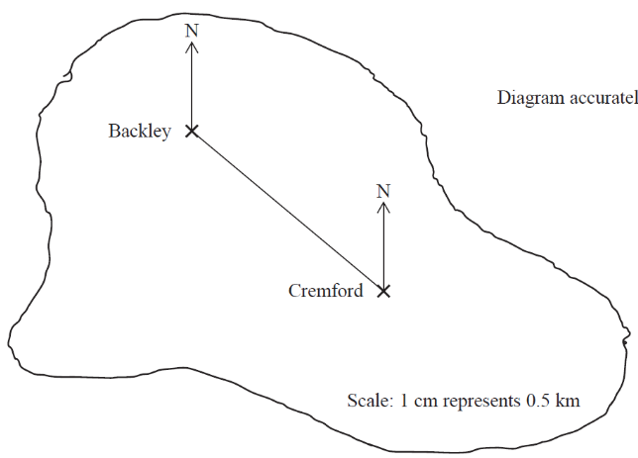 | 4. The size of the largest angle in a triangle is three times the size of the smallest angle. The other angle is 35° more than the smallest angle.  Work out, in degrees, the size of each angle in the triangle. You must show your working.
5. Choose a suitable operation to complete the calculation  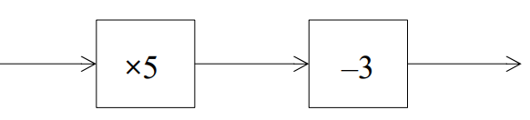  60  7  ?  X6 | 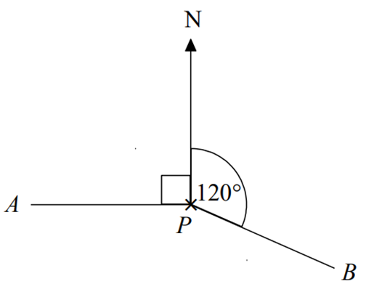  6. Find the bearing of B from P  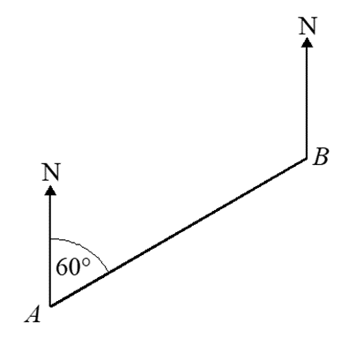  72º
7.  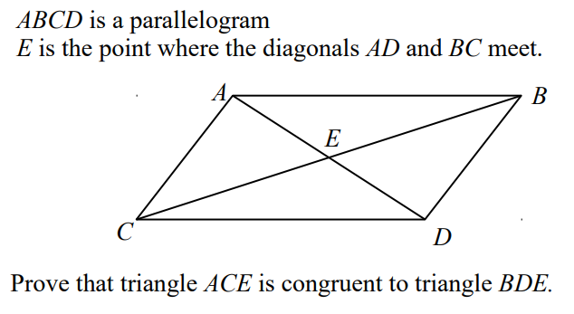 | 8. Expand and simplify  (x² - 5)(x³ - 8)
9. Factorise 30x³y + 12xy | 10. Simplify p²m⁶ ÷ m³
11. Find the lowest common multiple (LCM) of 72 ,90 and 126 | 12. Light A flashes every 4 seconds.  Light B flashes every 5 seconds.  Light C flashes every 6 seconds.  All three lights start at the same time.  Work out how long it will take for all three lights to flash at the same time again.
13. Write the gradient of the line:  3y = 2x + 8 | 14. Donald buys a pack of 9 chocolate bars. The pack costs £2.50  Donald sells all 9 chocolate bars for 45p each. Work out Donald’s percentage profit.
15. Amy is on holiday in Turkey She changes £200 to Turkish lira. The exchange rate is £1 = 7.7 Turkish lira Calculate how many Turkish lira Amy receives | 16. Expand and simplify:  (x + 2)(x + 4)(x + 1)
17. Jean invests some money in an account paying 3% compound interest for 3 years. Calculate how much money she invested if she finishes 3 years with £12020 | 18. Draw on a number line:  5 < x + 4 < 12
19. Lucy is three times as old as Alex. Lucy is 7 years older than Megan. The sum of their ages is 126. Find the ratio of Alex’s age to Lucy’s age to Megan’s age | 20. gp = 5g² - 2p  Make p the subject of the formula

WWW

EBI

EBI

