YEAR 11 HOMEWORK – 4S
BOOKLET 2

Complete the questions in each box. Make sure that you show all of your workings

1. Write $\frac{3}{25}$as a decimal. | 2. Write down a multiple of 8 that is between 50 and 60
3. Simplify 5f X 2 | 4. Ken buys some fruit. He buys apples, bananas, peaches and oranges.  Ken buys  4 apples weighing 130 g each  2 bananas weighing 120 g each  3 peaches weighing 110 g each  Each orange has a weight of 60 g. The fruit has a total weight of 1.390 kg.  Work out how many oranges Ken buys.
5. 80 students were asked how they get to school.  The table shows the results.  Bus Walk Car Bicycle  Number of students 20 25 10 25  Complete a pie chart for the information in the table. | 6. Annie and Lily share £54 in the ratio  5 : 4  What amount does Lily get?
7. What is the 5th prime number? | 8. Chrissy drew this graph to show the percentage of buses that got to a bus stop on time  for six months.  Write down one thing that is wrong with the graph  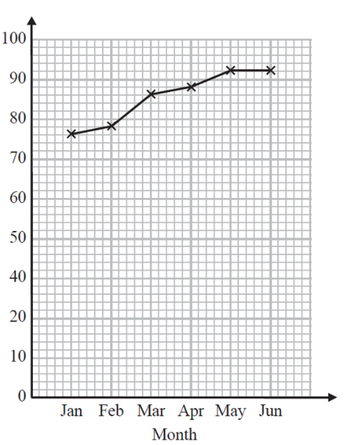  90  80  70  % of buses on time  60  50  40  30
9. Here is a map of an island. Work out the distance between the 2 villages  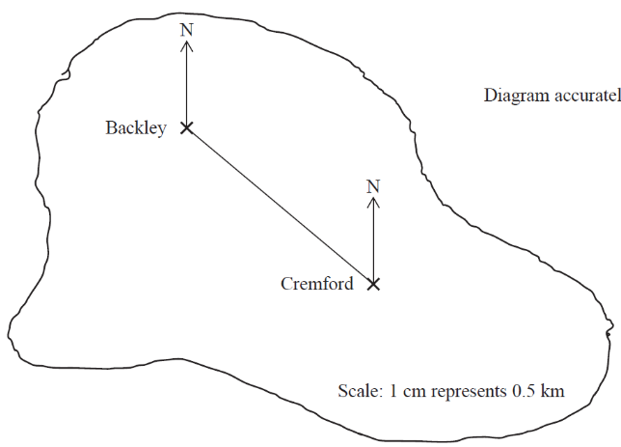  2cm represents 3km | 10. Find the shaded area of the shape  1.5cm  7cm  2cm  4cm
11. Write the mathematical name of the shape | 12. Simplify 2p x 3q
13. A cinema ticket costs £10b The price of a child’s ticket is one fifth the price of an adult ticket. Write an expression for the price, in pounds, of a child’s ticket | 14. Find the output if the input is  +2  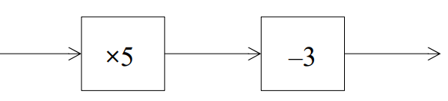  4  x-4
15. What goes in the gap?  -8 + ____ = 7 | 16. Solve 3x - 6 = 30

17. Find the bearing of A from B  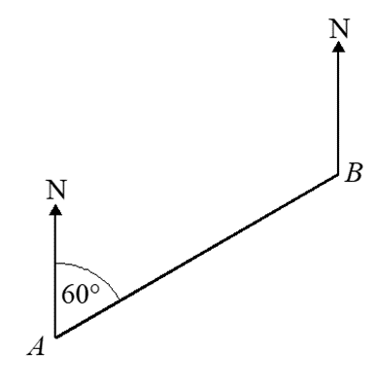  55º | 18. The triangles are similar. Find d
19. Expand and simplify  (x - 8)(x - 2) | 20. Factorise y² + 12y +11

WWW

EBI

EBI

