YEAR 11 HOMEWORK – 4T

BOOKLET 2

Complete the questions in each box. Make sure that you show all of your workings

1. Write $\frac{40}{50}$as a decimal. | 2. Write down a multiple of 8 that is between 40 and 50
3. Simplify 2ef X 4k | 4. Ken buys some fruit. He buys apples, bananas, peaches and oranges.  Ken buys  4 apples weighing 100 g each  2 bananas weighing 90 g each  3 peaches weighing 130 g each  Each orange has a weight of 140 g. The fruit has a total weight of 1390g.  Work out how many oranges Ken buys.
5. 160 students were asked how they get to school.  The table shows the results.  Bus Walk Car Bicycle  Number of students 60 40 20 40  Complete the pie chart for the information in the table. | 6. Annie and Lily share £70 in the ratio  2 : 5  How much of the money does Annie get?
7. Find the highest common factor:  27, 63 | 8. Chrissy drew this graph to show the percentage of buses that got to a bus stop on time for six months.  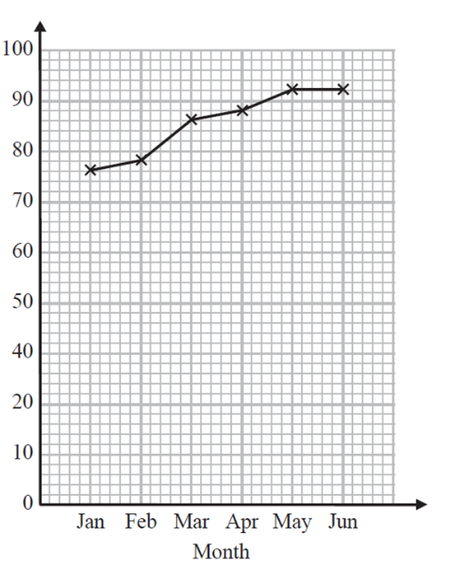  90  Write down one thing that is wrong with the graph  80  70  60  50  % of buses on time  40  30
9. Here is a map of an island. Work out the distance between the 2 villages  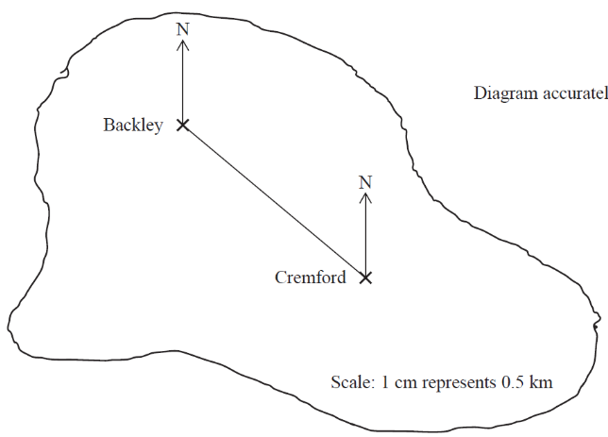  1cm represents 4 km | 10. Find the area of the shape  5cm  7cm
11. Write the mathematical name of the shape | 12. Simplify k + k² + 8 – 2k
13. A cinema ticket costs £8b The price of a child’s ticket is one quarter the price of an adult ticket. Write an expression for the price, in pounds, of a child’s ticket | 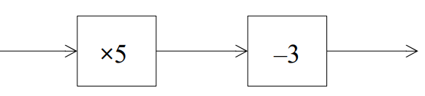  14. Find the input if the output is 25  +5  X2
15. 24 - ____ = 15 | 16. Solve 2x - 5 = 23

17. Write the 3-figure bearing of B from A  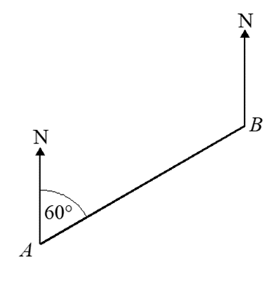  69 | 18. Use Pythagoras’ theorem to find “a”  9cm
19. Expand  -4(2x - 3) | 20. Write down the value of the 5 in the number 443.05

WWW

EBI

EBI

