YEAR 11 HOMEWORK – 6R
BOOKLET 2

Complete the questions in each box. Make sure that you show all of your workings

1. A rectangle has a length of 21cm to the nearest cm and a width of 5.3cm to the nearest mm. Work out the upper bound for the perimeter of the rectangle | 2. Complete the table and draw a pie chart:  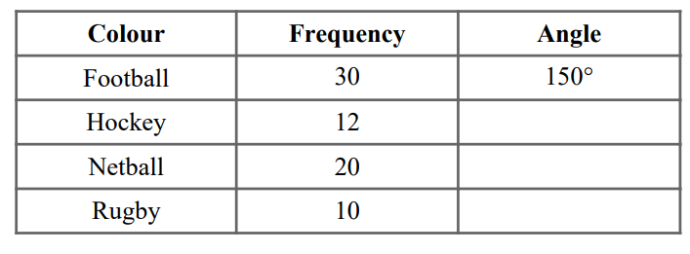
3. A model car has the length of 11cm.  The scale of the model is 1:35  Work out the length of the real car. Give your answer in metres.  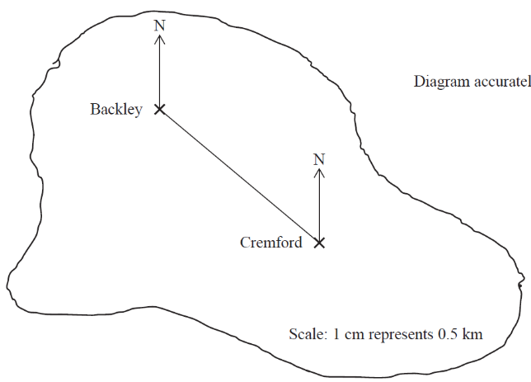 | 4. The size of the largest angle in a triangle is five times the size of the smallest angle. The other angle is 20° more than the smallest angle.  Work out, in degrees, the size of each angle in the triangle. You must show your working.
5. Here are the first five terms of a sequence.  31 27 23 19 15  Find the first negative term in the sequence | 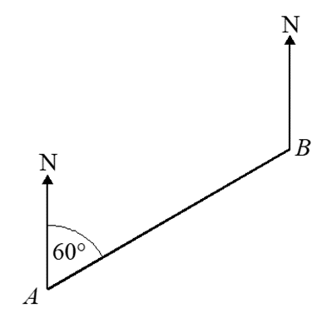  6. The bearing of London from Liverpool is 130° Find the bearing of Liverpool from London.
7. Brian bought a hat in France. He paid €45 The same hat in England costs £39.99 The exchange rate is £1 = €1.12 Is the hat cheaper in France or in England? You must show your working. | 8. Expand and simplify  (3x + 8)²
9. Factorise 30a³b + 40a²b | 10. Simplify p²m⁴ ÷ pm³
11. Find the lowest common multiple (LCM) of 12, 15 and 27. | 12. Light A flashes every 6 seconds.  Light B flashes every 7 seconds.  Light C flashes every 8 seconds.  All three lights start at the same time.  Work out how long it will take for all three lights to flash at the same time again.
13. Write the intercept of the line:  2y = 4x + 9 | 14. In a sale, normal prices are reduced by 15%. The normal price of a coat is reduced by £18 Work out the normal price of the coat.
15. A pair of trainers cost 3400 rupees in India. The same pair of trainers cost £68 in the UK. The exchange rate is £1 = 92 rupees. Work out the difference between the cost of the trainers in India and in the UK. Give your answer in pounds (£). | 16. Expand and simplify:  (x + 1)(x - 5)(x + 3)
17. A population of bacteria is increasing by 6% each hour. Find the percentage increase in the population every 3 hours | 18. Draw on a number line:  7 < 2x - 1 < 13
19. Mr Lee left his fortune to his 3 sons, 4 daughters and his wife. Each daughter received twice as much as each son and his wife received £8500, which was quarter of the money. How much did each son receive? | 20. Make b the subject:  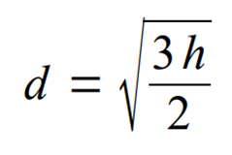

WWW

EBI

EBI

