YEAR 11 HOMEWORK – 6S
BOOKLET 2

Complete the questions in each box. Make sure that you show all of your workings

1. Write $\frac{6}{20}$as a decimal. | 2. Write down a multiple of 7 that is between 140 and 150
3. Simplify 3d² X 2d | 4. Ken buys some fruit. He buys apples, bananas, peaches and oranges.  Ken buys  5 apples weighing 100 g each  2 bananas weighing 115 g each  4 peaches weighing 110 g each  Each orange has a weight of 70 g. The fruit has a total weight of 1.45 kg.  Work out how many oranges Ken buys.
5. 55 students were asked how they get to school.  The table shows the results.  Bus Walk Car Bicycle  Number of students 12 14 8 21  Complete a pie chart for the information in the table. | 6. Annie and Lily share £78 in the ratio  1 : 5  What amount does Annie get?
7. Write a square number between 10 and 30. | 8. Chrissy drew this graph to show the percentage of buses that got to a bus stop on time for six months.  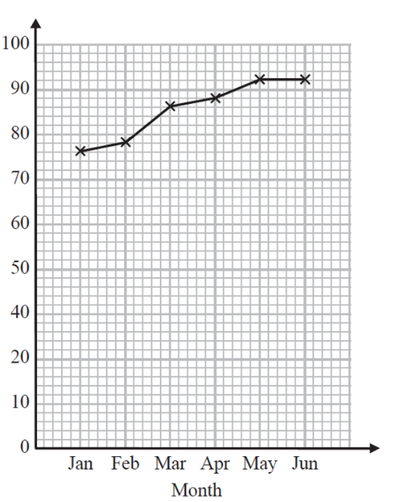  90  In July 75% were on time. Complete the graph  80  70  % of buses on time  60  50  40  30
9. Here is a map of an island. Work out the distance between the 2 villages  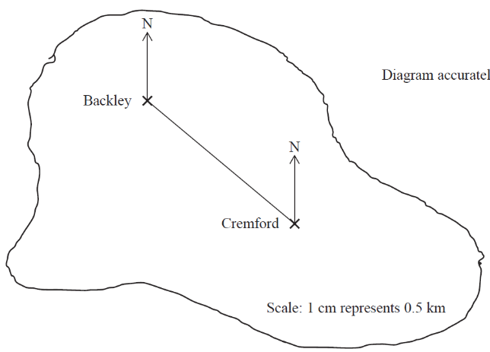  5cm represents 4km | 10. Find the shaded area of the shape  2cm  1.5cm  7cm  4cm
11. Write the mathematical name of the shape  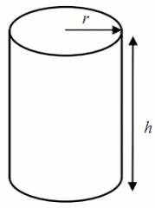 | 12. Simplify 2p² x 3p
13. A cinema ticket costs £20b² The price of a child’s ticket is one fifth the price of an adult ticket. Write an expression for the price, in pounds, of a child’s ticket | 14. Find the input if the output is  -2  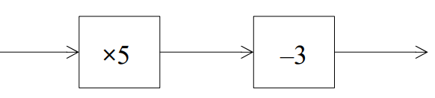  19  X3
15. What goes in the gap?  -8 x ____ = -32 | 16. Solve 4(x – 5) = 20

17. Find the bearing of A from B  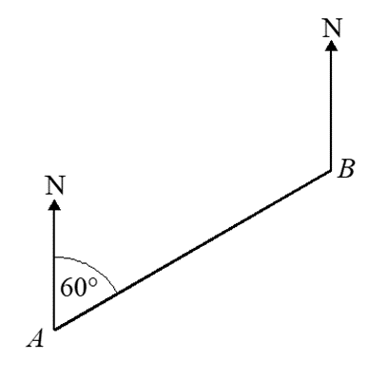  74º | 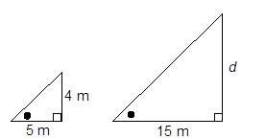  18. The triangles are similar. Find d  25m
19. Expand and simplify  (x + 5)(x - 3) | 20. Factorise y² - 4y

WWW

EBI

EBI

