YEAR 11 HOMEWORK – 6T

BOOKLET 2

Complete the questions in each box. Make sure that you show all of your workings

1. Write $\frac{20}{25}$as a decimal. | 2. Write down a multiple of 4 that is between 30 and 40
3. Simplify 2f X f² | 4. Ken buys some fruit. He buys apples, bananas, peaches and oranges.  Ken buys  6 apples weighing 120 g each  4 bananas weighing 100 g each  3 peaches weighing 130 g each  Each orange has a weight of 125 g. The fruit has a total weight of 1.885kg.  Work out how many oranges Ken buys.
5. 40 students were asked how they get to school.  The table shows the results.  Bus Walk Car Bicycle  Number of students 20 10 5 5  Complete the pie chart for the information in the table. | 6. Annie and Lily share £160 in the ratio  3 : 5  How much of the money does Lily get?
7. Find the highest common factor:  36, 16 | 8. Chrissy drew this graph to show the percentage of buses that got to a bus stop on time for six months.  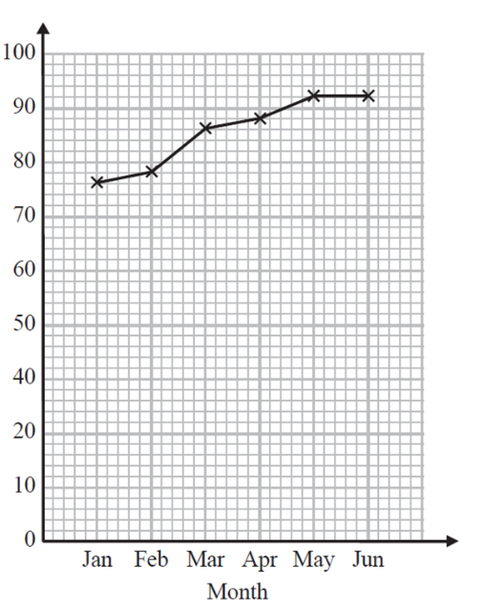  90  Write down one thing that is wrong with the graph  80  70  60  50  % of buses on time  40  30
9. Here is a map of an island. Work out the distance between the 2 villages  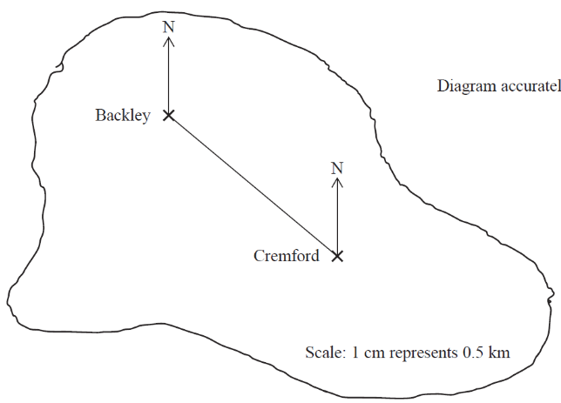  2cm represents 5 km | 10. Find the area of the shape  4.5cm  8cm
11. Write the mathematical name of the shape  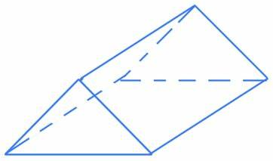 | 12. Simplify k + k² + 8 – 2k
13. A cinema ticket costs £5b The price of a child’s ticket is one third the price of an adult ticket. Write an expression for the price, in pounds, of a child’s ticket | 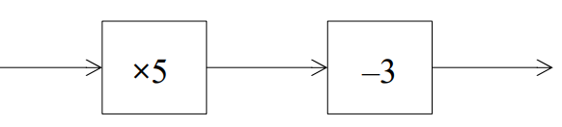  14. Find the input if the output is 26  -6  X2
15. 12 - ____ = 15 | 16. Solve 31 = 3p - 5

17. Write the 3-figure bearing of A from B  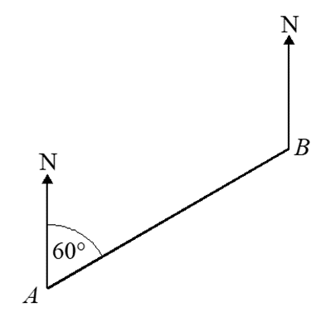  65 | 18. Use Pythagoras’ theorem to find “a”  4cm  4cm
19. Expand  -4(-x + 5) | 20. Write down the value of the 5 in the number 5443.01

WWW

EBI

EBI

