YEAR 11 HOMEWORK – WEEK ___

1. There are 3 rods of length:  a-1, 2a and a + 4  The total length of the 3 rods is L cm  Find a formula for L. Write it in its simplest form. |  | 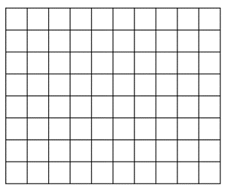  2. The length of a rectangle is twice as long as the width of the rectangle. The area of the rectangle is 32units². Draw the rectangle on the grid.
3. Jacqui wants to work out 3480÷5  She knows that 3480 ÷ 10 = 348  She writes: 3480 ÷ 5 = 174  Because: 10 ÷ 5 = 2  And: 348 ÷ 2 = 174  What mistake did Jacqui make in her method? |  | 4. Jake played a game 20 times. The stem and leaf diagram shows his scores  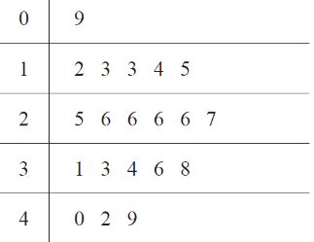  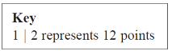  Jake says the modal score was 6 points. Explain his mistake
5. There are 30 children in a nursery school.  At least 1 adult is needed for every 8 children in the nursery.  Work out the least number of adults needed in the nursery. | 6. An approximate rule for converting degrees Fahrenheit into degrees Centigrade is:  Use this rule to convert 22°F into °C.
7. Write 36 as a product of its prime factors. | 8. Kiaria is 7 years older than Jay.  Martha is twice as old as Kiaria.  The sum of their three ages is 77  Find the ratio of Jay’s age to Kiaria’s age to Martha’s age.
9. ABCD is a parallelogram.  EDC is a straight line.  F is the point on AD so that BFE is a straight line.  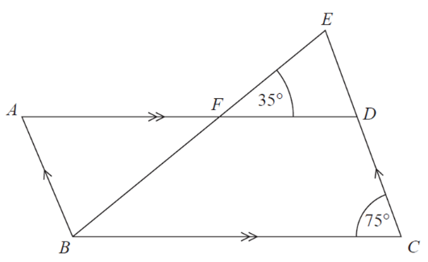  Find angle ABF | 10. Each circle has centre O. Daisy says that exactly 1/3  of the logo is shaded. Is Daisy correct?  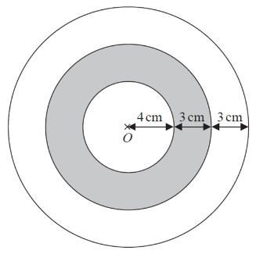  You must show all your working.

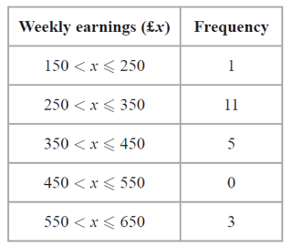  11. The table shows information about the weekly earnings of 20 people. Work out an estimate for the mean of the weekly earnings. | 12.  Solve the equation x2 + 3x− 40 = 0
13. Solve the inequality  5x + 3 > 10 | 14. A bag contains 200 coloured discs. The discs are either red, blue or yellow. There are 86 red discs in the bag. The probability that a blue disc is chosen from the bag is 0.22  Calculate the number of yellow discs in the bag.
15. y is proportional to x where x > 0 and y > 0. When x = 5, y = 12.5.  Find an equation expressing y in terms of x. | 16. Tim drives at an average of 80km per hour for 3 hrs 45 minutes. Work out how many kilometres he drives

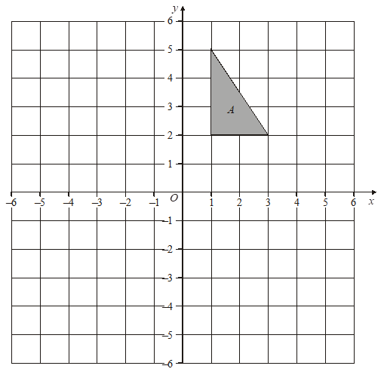  17. Draw the new position of triangle A after a rotation of 90° clockwise about the origin. | 18. Triangles ABC and DEF are similar.  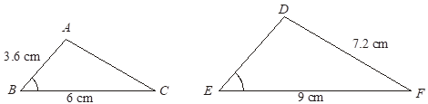  Calculate the length of DE.
19. Use Pythagoras theorem to find the value of a | 20. Write down the exact value of:  a) Sin 30  b) Sin 45  c) Tan 30

