YEAR 11 HOMEWORK – WEEK ___

1. Change 150 cm into metres. | 2. 2 + 7 × 10
3. Solve = 12  y  4 | 4. Here are four numbers.  -9 -2 2 9  Write one number in each box to make a correct calculation:  = -7  +

5. Here are the first four terms of a number sequence.  2, 5, 11, 23  The rule to continue the sequence is “multiply the previous term by 2 and then add 1”. Work out the 5th term of this sequence | 6. There are 3 rods of length:  a,  2a  4a  The total length of the 3 rods is L cm  Find a formula for L. Write it in its simplest form.
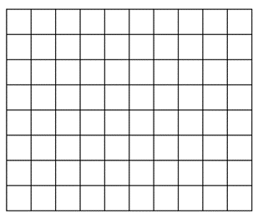  7. The length of a rectangle is twice as long as the width of the rectangle. The area of the rectangle is 8 units². Draw the rectangle on the grid. | 8. Jacqui wants to work out 3480÷5  She knows that 3480 ÷ 10 = 348  She writes: 3480 ÷ 5 = 174  Because: 10 ÷ 5 = 2  And: 348 ÷ 2 = 174  What mistake did Jacqui make in her method?
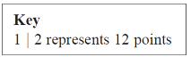  9. Jake played a game 20 times. The stem and leaf diagram shows his scores  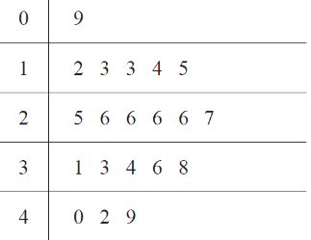  Jake says the modal score was 6 points. Explain his mistake | 10. There are 30 children in a nursery school.  At least 1 adult is needed for every 8 children in the nursery.  Work out the least number of adults needed in the nursery.

11. An approximate rule for converting degrees Fahrenheit into degrees Centigrade is:  Use this rule to convert 22°F into °C. | 12. Use the formula a = 5b + 2c to work out a when b = 3 and c = –4
13. Mark, with an X, an obtuse angle on the diagram. | 14. Work out the value of X  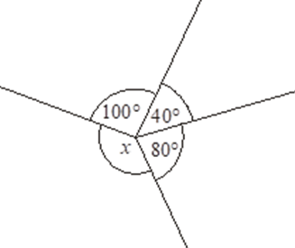
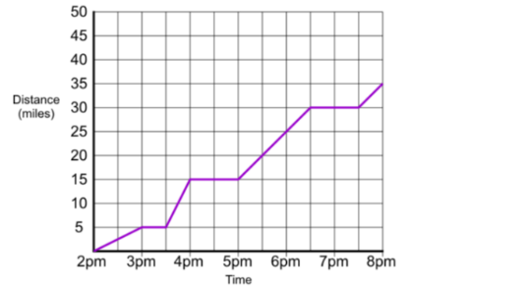  15. Complete this table of values for y = 2x – 1 | 16. The graph represents a journey made by Jenny. Work out the total time Jenny is not moving.
  x | –1 | 0 | 1 | 2 | 3
  y | –3 |  | 1 |  | 5

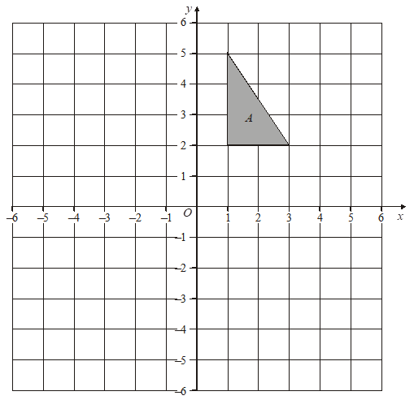  17. Draw the new position of triangle A after a rotation of 90° clockwise about the origin. | 18. A 4 pack of toilet roll costs £2.04  A 9 pack costs £4.50. Work out what one roll costs in each offer to determine which pack is better value.
19. Work out the area of the triangle | 20. Change 12 out of 20 to a percentage

