YEAR 11 HOMEWORK – 1T
BOOKLET 3

Complete the questions in each box. Make sure that you show all of your workings

1. Write 3758 correct to the nearest 1000 | Use this space on the right for your answers
2. Simplify y + 3y – 2y

3. Write down all the factors of 18

Cinema Ticket | Price
Adult ticket | £7.80
Child ticket | £5.80
Family ticket | £24.30
4. The table gives information about the prices of cinema tickets

Mr Edwards and his 3 children go to the cinema. It is cheaper for Mr Edwards to buy 1 family ticket rather than 4 separate tickets.
(a) How much cheaper?
The film starts at 6.45 pm. The film lasts 102 minutes. (b) What time does the film finish?
5. Find the lowest common multiple (LCM) of 70 and 56

6. Thais has a large bottle of shampoo. There are 2 litres of shampoo in the large bottle. Thais also has some empty small bottles. Each small bottle can be completely filled with 150 ml of shampoo. How many small bottles can be completely filled with shampoo from the large bottle?

7. The incomplete pictogram shows information about the number of cycles sold in a shop on Tuesday, on Wednesday and on Thursday.  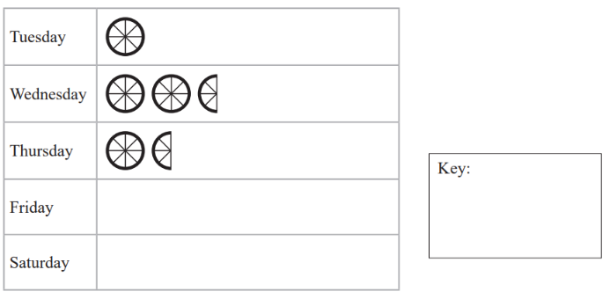  A total of 20 cycles were sold on Tuesday, Wednesday and Thursday. 8 cycles were sold on Friday. | 15 cycles were sold on Saturday. Use this information to complete the pictogram.
8.

117º
54º

BCD is a straight line. ABC is a triangle. Show that triangle ABC is an isosceles triangle. Give a reason for each stage of your working.
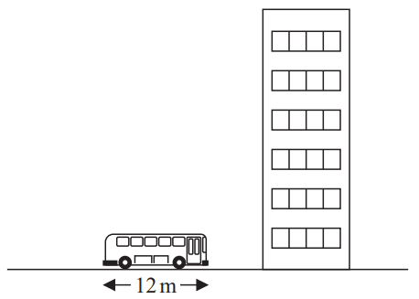
9.

The picture shows a bus next to a building. The bus has a length of 12 m. The bus and the building are drawn to the same scale. Work out an estimate for the height, in metres, of the building.
10. Nidah writes down two different prime numbers. She adds together her two numbers. Her answer is a square number less than 30 Find two prime numbers that Nidah could have written down.

WWW

EBI

EBI

