YEAR 11 HOMEWORK – 2T
BOOKLET 3

Complete the questions in each box. Make sure that you show all of your workings

1. Write 44798 correct to the nearest 1000 | Use this space on the right for your answers
2. Simplify 2y + 3y – y

3. Write down all the factors of 36

Cinema Ticket | Price
Adult ticket | £7.85
Child ticket | £5.85
Family ticket | £25.10
4. The table gives information about the prices of cinema tickets

Mr Edwards and his 3 children go to the cinema. It is cheaper for Mr Edwards to buy 1 family ticket rather than 4 separate tickets.
(a) How much cheaper?

The film starts at 6.45 pm. The film lasts 114 minutes.
(b) What time does the film finish?
5. Find the lowest common multiple (LCM) of 14 and 21

6. Thais has a large bottle of shampoo. There are 2 litres of shampoo in the large bottle. Thais also has some empty small bottles. Each small bottle can be completely filled with 175 ml of shampoo. How many small bottles can be completely filled with shampoo from the large bottle?

7. The incomplete pictogram shows information about the number of cycles sold in a shop on Tuesday, on Wednesday and on Thursday.  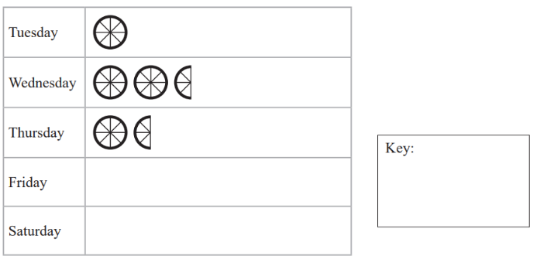  A total of 30 cycles were sold on Tuesday, Wednesday and Thursday. 9 cycles were sold on Friday. | 12 cycles were sold on Saturday. Use this information to complete the pictogram.
8.

64º
122º

BCD is a straight line. ABC is a triangle. Show that triangle ABC is an isosceles triangle. Give a reason for each stage of your working.
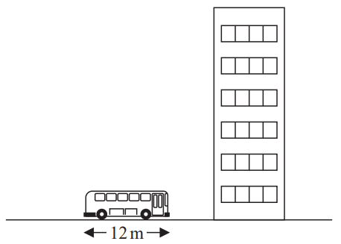
9.

8m
The picture shows a bus next to a building. The bus has a length of 8 m. The bus and the building are drawn to the same scale. Work out an estimate for the height, in metres, of the building.
10. Which is biggest 2³ or 3²

WWW

EBI

EBI

