YEAR 11 HOMEWORK – 2R
BOOKLET 3

Complete the questions in each box. Make sure that you show all of your workings

1. The table shows information about the heights of 80 children  Frequency  a)Find the class interval that contains the median _____________________  b) Draw a frequency polygon for the information in the table --> | 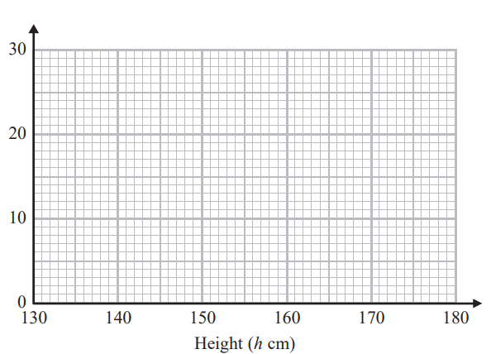  Use this space on the right for your answers
  Height (h cm) | Frequency
  130<h≤140 | 2
  140<h≤150 | 15
  150<h≤160 | 24
  160<h≤170 | 17
  170<h≤180 | 22
2. In London, 1 litre of petrol costs 118.9p
In New York, 1 US gallon of petrol costs $2.96
1 US gallon = 3.785 litres
£1 = $1.46
In which city is petrol better value for money, London or New York? You must show your working.

3. A gold bar has a mass of 10.5 kg.
The density of gold is 19.3 g/cm³ Work out the volume of the gold bar. Give your answer correct to 3 significant figures.

4. There are only blue pens, green pens and red pens in a box. The ratio of the number of blue pens to the number of green pens is 2 : 3. The ratio of the number of green pens to the number of red pens is 4 : 1. There are less than 100 pens in the box. What is the greatest possible number of red pens in the box?

5. (a) Find the value of the reciprocal of 1.8 Give your answer as a decimal to the nearest 3d.p

Jess rounds a number, x, to one decimal place. The result is 7.6
(b) Write down the error interval for x

6. Here is a rectangle  The length of the rectangle is 6 cm longer than the width of the rectangle. 4 of these rectangles are used to make this 8-sided shape. | The perimeter of the 8-sided shape is 70 cm. Work out the area of the 8-sided shape.
7. Work out
(3.8 × 10⁶ ) × (5.8 × 10⁻¹¹)
Give your answer as an ordinary number.

8. Lucy, Mel and Tom each dropped the drawing pin a number of times. The table shows the number of times the drawing pin landed point down and the number of times the drawing pin landed point up for each person. | The theoretical probability that the drawing pin will land point up is 2/3. Tom says his results show that his drawing pins are biased. Is he correct? Give a reason for your answer.
   | Lucy | Mel | Tom
  Point up | 31 | 53 | 35
  Point down | 14 | 27 | 7
9. Jack bought a new boat for £12,500
The value, £V, of Jack’s boat at the end of n years is given by the formula V = 12,500 × (0.80)^{n}
At the end of how many years was the value of Jack’s boat first less than 50% of the value of the boat when it was new?
10. There are blue, yellow, green and red counters in a bag. A counter is taken at random from the bag. The table shows the probabilities of getting a blue counter or a yellow counter or a green counter
Colour | blue | yellow | green | red
Prob | 0.2 | 0.3 | 0.4
a) Work out the probability of getting red
b) What is the least possible number of counters in the bag? You must give a reason for your answer.

WWW

EBI

EBI

