YEAR 11 HOMEWORK – 3T
BOOKLET 3

Complete the questions in each box. Make sure that you show all of your workings

1. Write 6769 correct to the nearest 100 | Use this space on the right for your answers
2. Simplify 8y + 3y – p

3. Write down all the factors of 80

Cinema Ticket | Price
Adult ticket | £7.65
Child ticket | £5.90
Family ticket | £25.15
4. The table gives information about the prices of cinema tickets

Mr Edwards and his 3 children go to the cinema. It is cheaper for Mr Edwards to buy 1 family ticket rather than 4 separate tickets.
(a) How much cheaper?

The film starts at 6.50 pm. The film lasts 124 minutes.
(b) What time does the film finish?
5. Find the lowest common multiple (LCM) of 8, 10 and 12

6. Thais has a large bottle of shampoo. There are 2.5 litres of shampoo in the large bottle. Thais also has some empty small bottles. Each small bottle can be completely filled with 125 ml of shampoo. How many small bottles can be completely filled with shampoo from the large bottle?

7. The incomplete pictogram shows information about the number of cycles sold in a shop on Tuesday, on Wednesday and on Thursday.  A total of 42 cycles were sold on Tuesday, Wednesday and Thursday. 14 cycles were sold on Friday. | 7 cycles were sold on Saturday. Use this information to complete the pictogram.
  Tuesday
  Wednesday
  Thursday
  Friday
  Saturday
8.
A

110º

Find the angle A
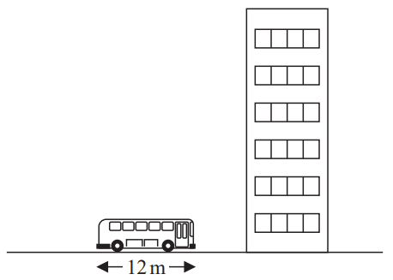
9.

11m
The picture shows a bus next to a building. The bus has a length of 11 m. The bus and the building are drawn to the same scale. Work out an estimate for the height, in metres, of the building.
10. Find the value of 3⁻¹

WWW

EBI

EBI

