YEAR 11 HOMEWORK – 4R
BOOKLET 3

Complete the questions in each box. Make sure that you show all of your workings

1. The table shows information about the heights of 80 children  Frequency  a)Find the class interval that contains the median _____________________  b) Draw a frequency polygon for the information in the table --> | 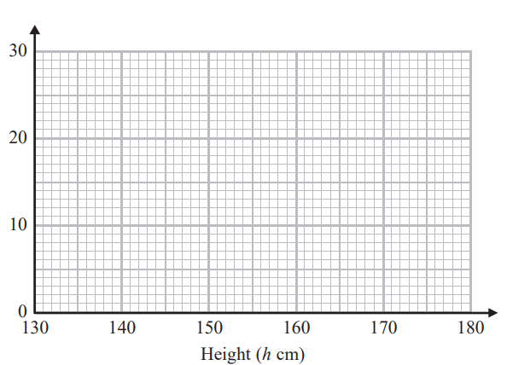  Use this space on the right for your answers
  Height (h cm) | Frequency
  130<h≤140 | 27
  140<h≤160 | 13
  160<h≤170 | 18
  170<h≤180 | 22
2. In London, 1 litre of petrol costs 116.9p
In New York, 1 US gallon of petrol costs $3.43
1 US gallon = 3.785 litres
£1 = $1.62
In which city is petrol better value for money, London or New York? You must show your working.

3. A gold bar has a volume of 1100cm³
The density of gold is 18.3 g/cm³ Work out the mass of the gold bar in kg. Give your answer correct to 3 significant figures.

4. Annie, Ben and Catlyn share £70. The amount Annie and Ben get is in the ratio 2:3. The amount Ben and Catlyn get is in the ratio 4:5. How much does Catlyn get?

5. (a) Find the value of the reciprocal of 5.7 Give your answer as a decimal to the nearest 3 sig figs

Jess rounds a number, x, to two decimal places. The result is 6.72
(b) Write down the error interval for x

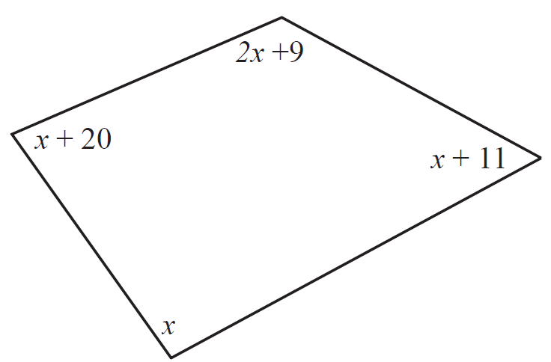
6.

a) Write down an equation in terms of x.
b) Use your answer to part (a) to work out the size of the smallest angle of the quadrilateral.
7. Work out
(2.8 × 10¹⁴ ) ÷ (5.9 × 10⁷)
Give your answer as an ordinary number to 1 decimal place

8. Sami spins a particular spinner 100 times. The results are shown in the table.
Score | 1 | 2 | 3 | 4 | 5
Frequency | 13 | 15 | 16 | 42 | 14
Estimate the number of times he would expect to land on a 3 if he spins the spinner 500 times.

9. Robert bought his car 4 years ago. Each year the value of the car depreciates by 15%. The car is now worth £6294. Calculate how much the car was worth when it was new.

10. There are blue, yellow, green and red counters in a bag. A counter is taken at random from the bag. The table shows the probabilities of getting a blue counter or a yellow counter or a green counter
Colour | blue | yellow | green | red
Prob | 0.2 | 0.3 | 0.4
a) Work out the probability of getting red
b) There are 15 yellow counters in the bag. Calculate the total number of counters in the bag.

WWW

EBI

EBI

