YEAR 10 HOMEWORK – 1R
BOOKLET 4

Complete the questions in each box. Make sure that you show all of your workings

1. Work out 25.68 ÷ 12 | Use this space on the right for your answers
2. Work out $\frac{3}{8}$ x 11

Give your answer as a mixed number

3. A triangle has perimeter 32cm  A square has perimeter 40cm  Two sides of the shapes are put together to make a pentagon. | Work out the perimeter of the pentagon
4. A football team has P points.
P = 3W + D

W is the number of wins D is the number of draws

a) A team has 6 wins and 2 draws. How many points does the team have?

b) After 33 games a different team has 53 points. 11 games were draws. How many games has this team lost?

5. A number is picked at random from the first four prime numbers. A number is picked at random from the first four square numbers. The two numbers are added to get a score. | a) Complete the table.  b) What is the probability that the score is a prime number?
   | 1 | 4 | 9
  2
  3 |  |  | 12
  7
6. In a school show,
girls : boys = 1 : 1
girls who sing : girls who do not sing = 1 : 2

8 girls sing in the show.
How many students are in the show altogether?

7. P and Q are points on the line 3x + 2y = 6  P ( 0 , ___) Q (___ , 0 )  Draw 3x + 2y = 6  for values of x from –3 to 3 | 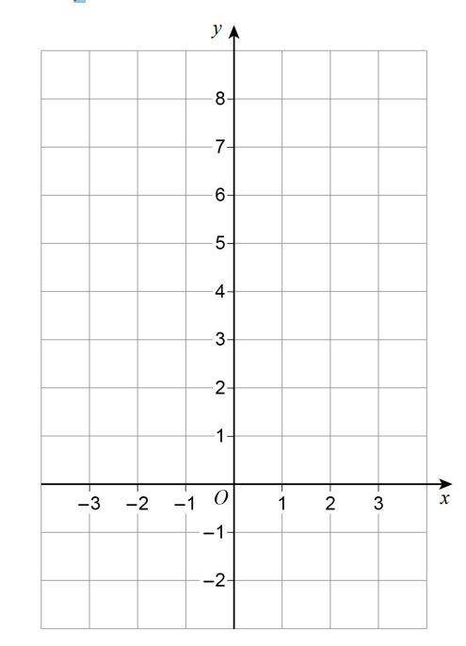
8. Use 8 km/h = 5 mph to convert 96 km/h to mph

9. Here is a circle touching a square.
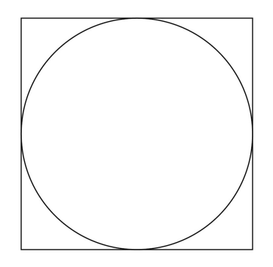

The area of the square is 64 cm² Work out the area of the circle. Give your answer in terms of π.
10. Billy wants to buy these tickets for a show.
4 adult tickets at £15 each
2 child tickets at £10 each
A 10% booking fee is added to the ticket price.
3% is then added for paying by credit card.
Work out the total charge for these tickets when paying by credit card.

WWW

EBI

EBI

