YEAR 11 HOMEWORK – 6R
BOOKLET 4

Complete the questions in each box. Make sure that you show all of your workings

1. Nick bought a new classic car. Each year the car appreciates in value by 8%. Work out the number of years it takes for the car to increase by a quarter of its initial value. | Use this space on the right for your answers
2. In London potatoes cost £0.58 per lb. In Dublin potatoes cost €1.38 per kilogram.

1 kg = 2.2 lbs
£1 = €1.11

In which city are potatoes better value for money, London or Dublin? You must show your working.

3.
The diagram shows a patio in the shape of a rectangle.
4.2 m
1.6m

Jack wants to cover the patio with paving slabs.
Each paving slab is a square of side 40 cm.
The paving slabs cost £7.59 each.
Jack has £300 to spend on paving slabs.
Does Jack have enough money to cover the patio with paving slabs.

4.
a)Use your calculator to work out
$$√(\frac{\sin{52°+1}}{\cos{68°+1}})$$
Write down all the figures on your calculator display.

(b) Write your answer to part (a) correct to 3 significant figures.

5. Lucy is four times as old as Alex.
Lucy is 7 years older than Megan.
The sum of their ages is 146.
Find the ratio of Alex’s age to Lucy’s age to Megan’s age.

6. Find the equation of the line parallel to
4x + 5y = 15 which passes through (0,–4)

7. Carlos wants to find an estimate for the number of ants in a colony. He catches 65 ants from the colony and marks each one with a dye. He then returns the ants to the colony.
A week later, Carlos catches 40 ants. 8 of these ants are marked with the dye.
(a) Work out an estimate for the number of ants in the colony.

Carlos assumes that none of the marks had rubbed off. (b) If Carlos’s assumption is wrong, explain what effect this would have on your answer to part (a)

8. The table shows some information about times, in minutes, it took some boys to complete a puzzle  (a) Draw a box plot for this information.  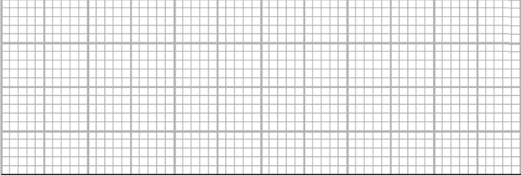 | Some girls also completed the puzzle. The box plot below shows the distribution of times the girls took to complete the puzzle.  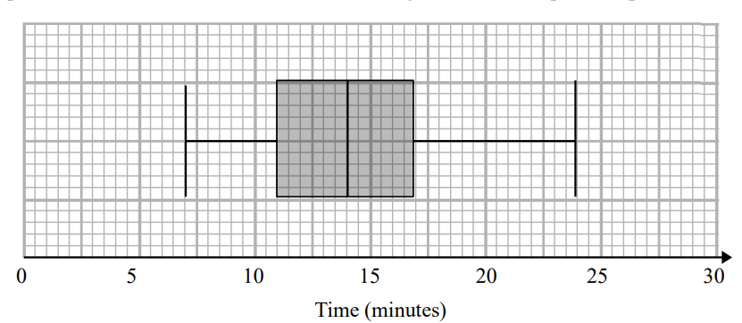  (b) Compare the distribution of girls' times and the boys' times.
  IQR | Minimum | Median | Upper Quartile | Maximum
  10 | 5 | 11 | 15 | 25
9. It takes 50 builders 25 days to complete a job.
(a) Work out how many days it would take 10 builders to complete the same job.

(b) Write down any assumption you made in part (a)

10. Given that f(x) = $\frac{4}{x+1}$and
g(x) = $\frac{1}{x-3}$
(a) Find gf(4)

(b) Work out an expression for f ⁻¹(x)

(c) Find fg(x)

WWW

EBI

EBI

