GCSE SUBJECT – AQA Combined Science Trilogy (8464)/ AQA Biology (8461), Chemistry (8462) and Physics (8463)
Assessment Structure | Date
Exam Paper 1 – Biology 1 | 16th May 2023
Exam Paper 2 – Chemistry 1 | 22nd May 2023
Exam Paper 3 – Physics 1 | 25th May 2023
Exam Paper 4 – Biology 2 | 9th June 2023
Exam Paper 2 – Chemistry 2 | 13th June 2023
Exam Paper 3 – Physics 2 | 16th June 2023

The key to doing well in this subject is:
- Knowing which topics each exam assesses and revising this content in advance
We have given every student a yellow A5 booklet that contains topic lists for each exam paper. These topic lists also have page references included, to point students to the correct pages of their revision guide.
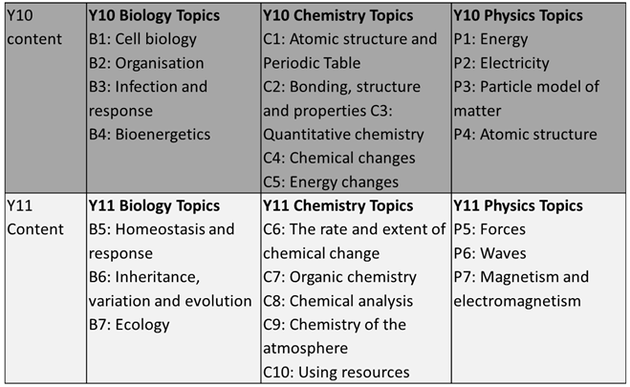
- Understanding the required practicals for each exam paper (15% of marks across all 6 papers)
We have provided pupils with a powerpoint that contains links to videos that show all the required practicals being done. This powerpoint can be accessed via the Science Revision Team
- Applying your maths skills
Biology- 20% Maths skills
Chemistry-30% Maths skills
Physics- 40% Maths skills
Other Top tips
All Y11 students have been invited to a Y11 Science revision team. Within this team there are electronic copies of all topic checklists, exam specifications, links to required practical videos and other revision materials that students may find useful to prepare for each exam.

There is also wealth of excellent online materials linked as tabs at the top of the Science Revision Team to help support Science revision. The websites are also listed below:
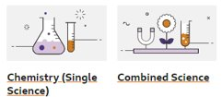 | BBC bitesize is a website or free to download app. It contains diagrams, explanations, animations and quizzes. This resource can be accessed via tablet or mobile phone, perfect for revision on the go! Select AQA Combined Science Trilogy or the separate Sciences for Triple  GCSE Combined Science - AQA Trilogy - BBC Bitesize  GCSE Biology (Single Science) - AQA - BBC Bitesize  GCSE Chemistry (Single Science) - AQA - BBC Bitesize  GCSE Physics (Single Science) - AQA - BBC Bitesize
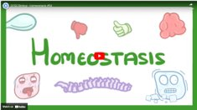 | COGNITO is a website that provides short videos explaining each topic, past exam papers and mark schemes and topic specific exam questions. Cognito (cognitoedu.org)
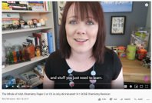 | PRIMROSE KITTEN is a YouTube channel and website that contains videos summarising the content for each exam. The narrator of the videos produces a vast range of free resources to help support revision as well as targeted videos for pupils aiming for grades 7,8 and 9 Primrose Kitten. Tutorials for Science and Maths | Primrose Kitten
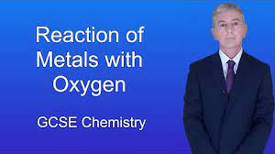 | FREE SCIENCE LESSONS is also a YouTube channel, plus linked website. Each topic is broken up into several short but fact packed video clips. It’s like having a science tutor on hand at any time of day! https://www.freesciencelessons.co.uk/
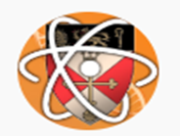 | MALMESBURY SCHOOL SCIENCE- YouTube channel. This school has made videos of all the required practical experiments pupils are expected to have completed by the end of Y11. These experiments for the basis of 15% of the exams so the channel is an excellent resource for revision. https://www.youtube.com/channel/UC-TM-z1-tmX1iK_H4SxVhww
 | SENECA- Online learning platform. Weekly revision homework is also set on Seneca, an online learning platform that provides videos, information and quiz questions relevant to the course we follow. Pupils can also access materials to self study from their courses, if they like the format of Seneca.

