L03 Assessment

(1) Fig. 1 shows what happens to data collected from a survey.
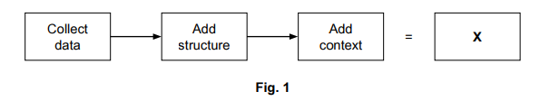
What does X represent?
..................................................................................................................................................... [1]
(2) What are the data types used in columns C and D in table 1?
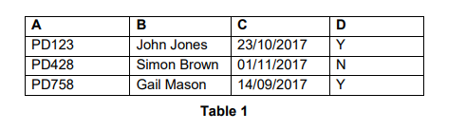
C =.....................................................................................................................................................
D=..................................................................................................................................................... [2]

(3) Progress X is an IT company that uses social media to promote its services. Identify two benefits to Progress X of using social media to promote its services.
Benefit 1: ..........................................................................................................................................
..........................................................................................................................................................
Benefit 2: ..........................................................................................................................................
.......................................................................................................................................................... [2]
(4)
A project team has to collect data about people’s use of a local bus route. The data has to be collected when people are using the bus.
The data will be used to decide if the buses are big enough, if the route is only used at certain times of the day or if the route needs more buses.
The collected and processed data will be given, as an integrated document, to an audience. The audience for the integrated document will include people who use the bus route, the transport department who provide the money to run the bus route and the company who provides the buses and drivers.
The collected data and processed results will be presented by a member of the project team at a community meeting with the data also being available online.

- The project team will use a tablet to collect the required data in a questionnaire. Describe one disadvantage of using a tablet to collect this data.
..................................................................................................................................................................
..................................................................................................................................................................
..................................................................................................................................................................
............................................................................................................................................................. [2]
b) Another way of collecting data is through the use of a sensor. Explain two advantages of using a sensor to collect the data when people use a bus route.
Advantage 1: ...........................................................................................................................................
..................................................................................................................................................................
Advantage 2: ...........................................................................................................................................
............................................................................................................................................................. [4]

(5) The company uses email to inform customers about special offers.
- Describe one advantage to the company of using email to provide information about special offers.
..................................................................................................................................................................
..................................................................................................................................................................
..................................................................................................................................................................
............................................................................................................................................................. [2]
- Identify one other IT method that the company could use to tell customers about special offers.
..................................................................................................................................................................
..............................................................................................................................................................[1]
- Why did you select this IT method?
..................................................................................................................................................................
..................................................................................................................................................................
............................................................................................................................................................. [2]

(6) What is meant by the term ‘secure backup of data’?
..................................................................................................................................................................
..................................................................................................................................................................
............................................................................................................................................................. [2]

(7) Describe both open and closed questions
Open .....................................................................................................................................................
..................................................................................................................................................... ...........
Closed .....................................................................................................................................................
..................................................................................................................................................... ........[4]

(8) A project manager needs to take electronic files to a meeting with a client. What physical storage device could the project manager use to take these electronic files to the meeting?
..................................................................................................................................................... [1]

(9) Explain the difference between primary and secondary research
..................................................................................................................................................................
..................................................................................................................................................................
..................................................................................................................................................................
............................................................................................................................................................. [3]

(10) Discuss whether a travelling salesman should use an SSD or ‘the cloud’ to store the files he needs for meetings.

..................................................................................................................................................................
..................................................................................................................................................................
..................................................................................................................................................................
..................................................................................................................................................................
..................................................................................................................................................................
..................................................................................................................................................................
..................................................................................................................................................................
..................................................................................................................................................................
..................................................................................................................................................................
..................................................................................................................................................................
..................................................................................................................................................................
..................................................................................................................................................................
............................................................................................................................................................. [9]
(11) Analyse the advantages and disadvantages of a Hard Disk Drive (HDD)

..................................................................................................................................................................
..................................................................................................................................................................
..................................................................................................................................................................
..................................................................................................................................................................
..................................................................................................................................................................
..................................................................................................................................................................
..................................................................................................................................................................
..................................................................................................................................................................
..................................................................................................................................................................
..................................................................................................................................................................
............................................................................................................................................................. [6]

(12) Explain why phone numbers are typically stored as string and not the integer data type

..................................................................................................................................................................
..................................................................................................................................................................
..................................................................................................................................................................
............................................................................................................................................................. [3]

