Storage Devices
Storage Devices – Storage devices are used to store files of data that a user wants to keep. Files of data may be letters, images, photographs, spreadsheet or database files, or any data that has to be kept after the computer has been switched off, or when the user has moved on to another task and wants to save the data for later use.

Cloud Storage | Solid State Drive (SSD) | Flash Memory | Magnetic Hard Disk Drive (HDD) | Optical Drive

Name of Device | Image of Device | Features of Device | Typical use of Device in a Business
 | 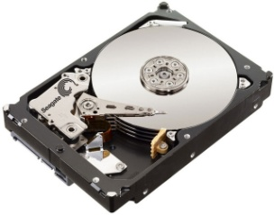 | Uses magnetic discs for storing software and data in files.  The discs are circular and spin at high speeds while drive heads read and write the date. This makes the discs susceptible to dirt and damage if moved suddenly.  The files can be read, edited, re-written or deleted.  Can store huge amounts of data. | Uses include:  - Storage of the operating system  - Storage of the files and data not in use at the time  - Storage of data, files and software when the computer is turned off  - Storing file such as a database of the details of members
 | 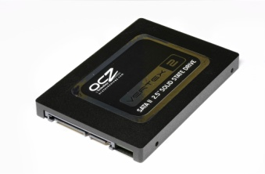 | Uses flash memory to store software and data in files.  There are no moving parts which make them faster and more reliable then magnetic hard disc drives and they are often found in portable computers such as netbooks and tablets.  They can store large amounts of data but not as much as hard disc drives. | Uses include:  - Storage of the operating system  - Storage of the files and software not in use at the time  - Storage of data, files and software when the computer is turned off
 | 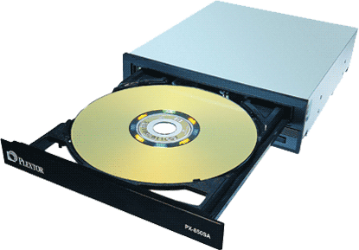 | An optical drive uses optical media such as CDs and DVDs to store software and data files.  The files can be read, edited, re-written or deleted only if CDR/RWs or DVD-R/RWs are used.  Data stored on CD-ROMs and DVD-ROMs can be read but altered.  Blu-ray discs are large capacity optical disks and can store very large amounts of data. | Uses include:  - Storage of files or data that have to be moved to another computer  - Storage software for installation on a computer  - Storage of data, files and software in backups or archives  Businesses may use writable or re-writable CDs or DVDs for storing backups and archives
 | 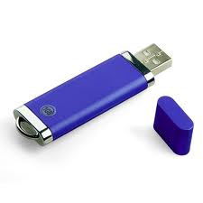 | Small memory sticks contain this type of memory and are used in USB ports.  They are used to store data and files for transfer to other computers or for taking away from, or back to, the office.  Similar devices are used in cameras and phones as memory cards. | Uses include:  - Saving a file onto a memory stick (flash memory device)  - Saving images on a digital camera  - Saving contact details in a phone
 | 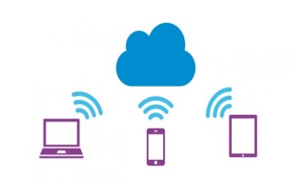 | Very large storage capacity facilities made available online so the data can be accessed remotely using a web interface. | Used to store files online that are shared between staff.

