History Year 7 Follow Up Homework Task
Restoration England
The Restoration period was a period of returning to the old ideas and beliefs.
Analyse the sources and explain what it tells us about Restoration England

Source | What does the source tell us about Restoration England?
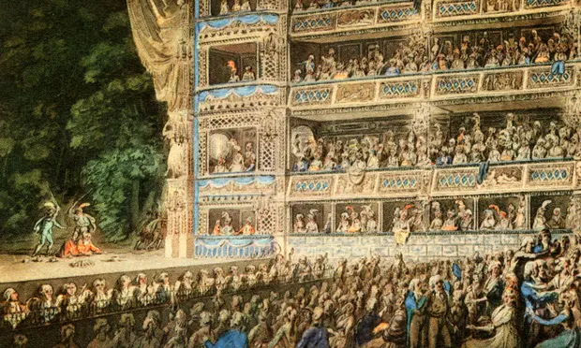 | A Theatre filled
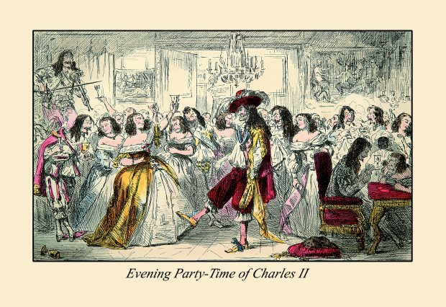 | Friends with Charles II, gambling, drinking etc
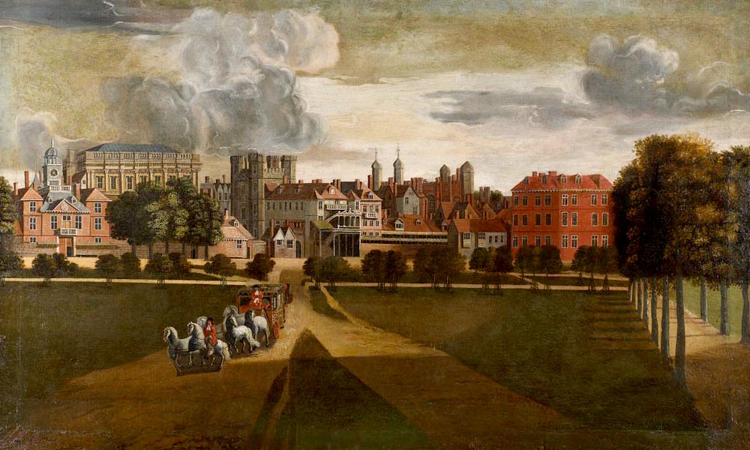 | A fine, Jacobean House
Challenge: Explain why life in Restoration England was interesting. Compare it to Puritan England, your previous homework.

