YEAR 10 HOMEWORK – 2T
BOOKLET 2

Complete the questions in each box. Make sure that you show all of your workings

- Find the area of the shape  6cm  6cm | - Simplify $\frac{10}{15}$
3. Find  2.23 + 0.72 | 4. Write down a multiple of 7 that is between 30 and 40
5. Round 238 to the nearest 10 | 6. Write the mathematical name of the shape
7. Multiply the fractions:  $\frac{2}{3}$ x $\frac{3}{7}$ | 8. Enter an inequality symbol in the box – either choose < or >  $\frac{1}{4}$ $\frac{3}{8}$
9. Add the fractions:  $\frac{2}{4}$ + $\frac{3}{8}$ | 10. Chrissy drew this graph to show the percentage of buses that got to a bus stop on time for six months.  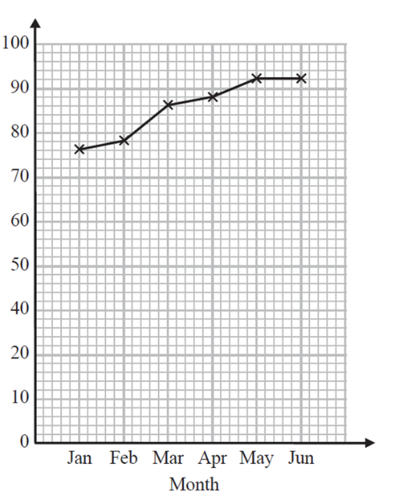  90  80  Write down one thing that is wrong with the graph  70  60  50  % of buses on time  40  30
11. Find the highest common factor:  8, 20  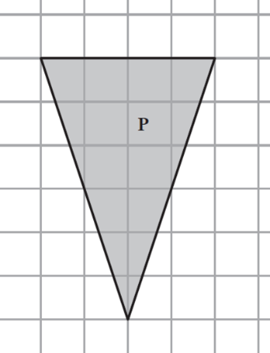 | 12. Find the output if the input is 4
13. 4 people order pizza. Each person will eat 3/8 of a pizza. How many do they need to order? | 14. Simplify k + k + k + p + p
15. A cinema ticket costs £2x for an adult. The price of a child’s ticket is half the price of an adult ticket. Write an expression for the price, in pounds, of a child’s ticket | 16. Here is a map of an island. Work out the distance between the 2 villages  1cm = 2km
17. What goes in the gap?  4 + ____ = 20 | 18. Solve x + 8 = 16
19. Expand  2(x + 4) | 20. Find $\frac{2}{7}$ of 140

WWW

EBI

EBI

