YEAR 10 HOMEWORK – 1

1.Find the perimeter:  5cm  5cm  2cm  1cm  3cm  2cm  3cm  5cm | 2. Find the Area:  10cm
3. Find the volume:  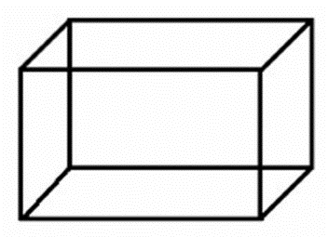  3m  5m  8m | 4. Simplify:  6k + 9k – 4k

5. Simplify 12X ÷ 3 | 6. Simplify 12X ÷ 3X
7. Write an expression for the perimeter in its simplest form  f  2f  2f | 8. Expand the brackets and simplify:  3(f + 7)
9. Fill in the blank in the bracket:  8p + 12 = 4(2p + ____ ) | 10. Find the value of P when x = 2 and y = 5:  P = 2x + 2y

11. Find the probability of a purple ball being pulled out if these are the probabilities of the other colours  Blue 0.1 Green 0.2  Red 0.3 Purple = | 12. Complete the two-way table.  Shaded Unshaded  Circles  Triangles 1  Total
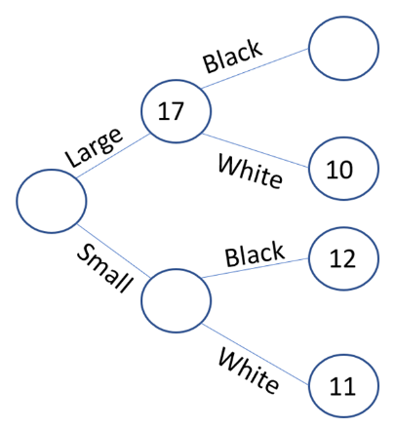  13. Fill in the blank circles | 14. In a card game Jayne wins 4 out of 10 games. Estimate how many games she would win out of 50.
15. In form 9H 14 students are studying Maths, 8 students are studying French, 6 are studying both and 3 students study neither.  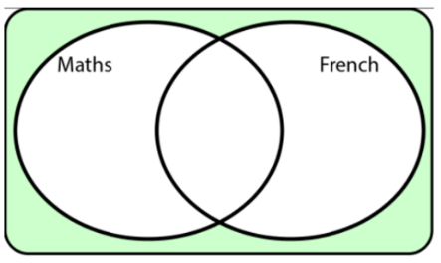  Complete the Venn diagram: | 16. Write the inequality shown on the number line  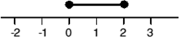
17. Write the following numbers in ascending order.  2.5, 2.24, 2.04, 1.39, 4.2 |  | 18. Round 2473 to the nearest 10
19. Write in its simplest form  20  12 |  | 20. Write the fractions in ascending order:  $\frac{3}{4}$ $\frac{1}{2}$ $\frac{1}{4}$ $\frac{3}{8}$ $\frac{5}{8}$

