YEAR 11 HOMEWORK – 2S
BOOKLET 3

Complete the questions in each box. Make sure that you show all of your workings

1. Thais has a large bottle of shampoo. There are 2 litres of shampoo in the large bottle. Thais also has some empty small bottles. Each small bottle can be completely filled with 175 ml of shampoo. How many small bottles can be completely filled with shampoo from the large bottle? | Use this space on the right for your answers
2. The incomplete pictogram shows information about the number of cycles sold in a shop on Tuesday, on Wednesday and on Thursday.  A total of 30 cycles were sold on Tuesday, Wednesday and Thursday. 9 cycles were sold on Friday. | 12 cycles were sold on Saturday. Use this information to complete the pictogram.
3.

122º
64º

BCD is a straight line. ABC is a triangle. Show that triangle ABC is an isosceles triangle. Give a reason for each stage of your working.
4.

8m
The picture shows a bus next to a building. The bus has a length of
8m. The bus and the building are drawn to the same scale. Work out an estimate for the height, in metres, of the building.
5. Which is biggest 2³ or 3²?

6. Jim thinks of a number. $\frac{2}{3}$
of Jim’s number is 32 Work out $\frac{5}{6}$ of Jim’s number.

7. Jack’s driving school has two offers.
Offer 2:
All driving lessons 10% off the normal price
Offer 1:
First driving lesson free
All other lessons normal price

The normal price of a driving lesson is £28 Douglas is going to have 12 driving lessons. Which is the cheaper offer for 12 driving lessons, Offer 1 or Offer 2? You must show how you get your answer.
8. 2.5 kg of apples cost £4.20 Work out the cost of 3.5 kg of apples.

9. a) Complete the table of values for  y = x + 1  x -2 -1 0 1 2 3  y  b) On the grid, draw the graph of  y = x + 1  for values of x from -2 to 3 | 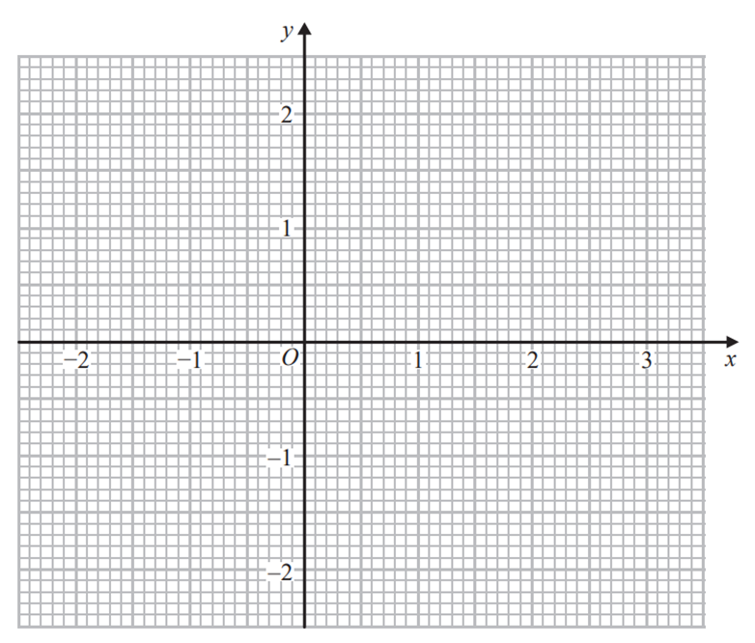  (c) Use your graph to find the value of x when y = 1.5
10.  4  3  B  A  2  1  -1  4  3  2  1  -1  -2  -3  -4  -2  -3 | Describe fully the single transformation that maps shape A onto shape B.
-4
WWW

EBI

EBI

