History Year 10 Pre Learning Homework Task
Examination Question Practise

Answer the following question

Challenge

How useful is the source for an enquiry into the reasons why the Cold War began? 4marks
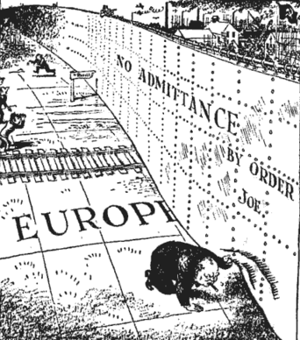

British Cartoonist , Leslie Illingworth March 1946 Daily Mail Newspaper

Nature, (what is it and how does that make it useful?)
Origin, (when was it written and how does that make it useful?)
Purpose, (why was it written and why does that make it useful?)
What does it tell us about why the Cold War began? Are there any features that can summarise the content of the source?
What about the historic context, is it what you expect to read? What do you know about the beginning of the Cold War. Make a judgement about how useful the source is?

