YEAR 10 HOMEWORK – 4T
BOOKLET 3

Complete the questions in each box. Make sure that you show all of your workings

1. Change 10,250g to kg. | Use this space on the right for your answers
2. Write 0.35 as a fraction.

3. Write down an even number that is a multiple of 9

4. Solve $\frac{x}{4}$ = 2

5. Solve -3x + 7 = 67

6. On the grid, draw a rhombus | 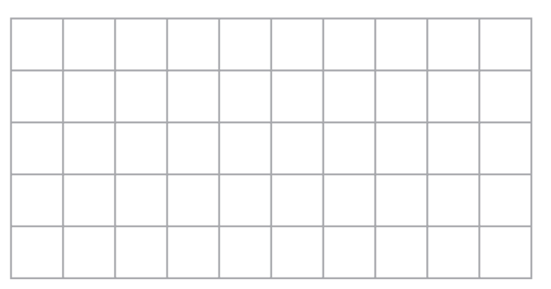
7. Write $\frac{18}{24}$ as a percentage.

8. Coffee is sold in jars. There are 500g of coffee in each jar. Ben makes 5 cups of coffee each day. He thinks he uses 2.5g of coffee to make each cup of coffee. Ben wants to buy enough coffee for 25 days.
(a) How many jars of coffee does Ben need to buy?

b) Ben finds that he uses 2.8 g of coffee to make each cup of coffee. How much extra coffee has he used?

9. Write down three different factors of 81

10. A model plane has a length of 120cm. The scale of the model is 1:30 Work out the length of the real plane. Give your answer in metres.

WWW

EBI

EBI

