History Year 10 Recap Recall Homework Task
Examination Question Practise

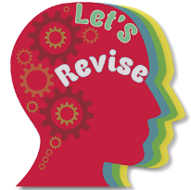

Describe two features of Black Power 4 marks

Challenge: Why was Black Power a ‘threat’ to mainstream America?

