Reading Guitar Chord Charts

1. A chord is ___________________ played together.
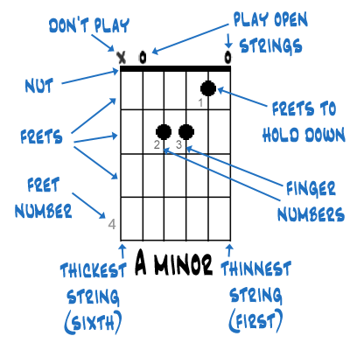

Finger Numbers | Nut | Thinnest String (1st)
Frets to Hold Down | Play Open Strings | Thickest String (6th)
Frets | Don’t Play | Fret Number

Common Chord Shapes
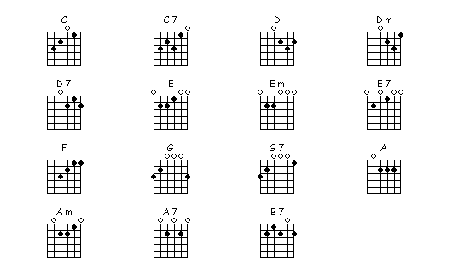
Write out the following chords:
E minor
A
G
D minor
C
E
A minor
D

