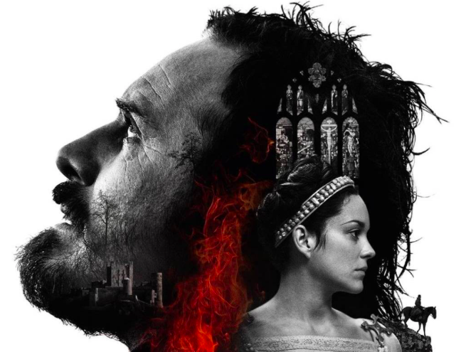

Year 11
Macbeth Revision
Name_________________
Teacher____________

Everything you need to know…
This booklet aims to make sure you have a really confident understanding of Macbeth.
By the end of the booklet, you will have:

- A solid understanding of the plot and characters in Macbeth
- Some excellent vocabulary with which to write about the characters
- A good understanding of the ‘big ideas’ Shakespeare was writing about
- Memorised key quotations and facts about when Shakespeare was writing

And that’s it; you’ll be all clued up!

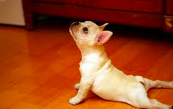
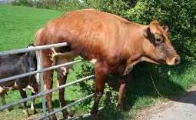
STUCK? STRETCH!
These sections help you get un-stuck These sections aim for top marks

1) PLOT REVISION
First task:
- Go to YouTube and search ‘Cliffnotes Macbeth Cambio Bosy.’
- Listen to the video
- Pause it, and replay parts if you need to, to complete the boxes below. In each box, add in what you think are the main 5 things that happen in that act.

Main events in Act 1

- Example: Macbeth and Banquo meet 3 witches on the way back from battle
-
-
-
-

Main events in Act 2

-
-
-
-
-

Main events in Act 3

-
-
-
-
-
Main events in Act 4

-
-
-
-
-

Main events in Act 5

- Example: Macbeth and Banquo meet 3 witches on the way back from battle
-
-
-
-

STUCK?  Use what you have seen in the video to complete a comic strip version of the plot, with 8 pictures. Explain what is happening in each picture. | STRETCH!  What are the turning points in the plot of Macbeth? A ‘turning point’ is a part of the play where a character changes; they see things in a different way, or something happens that has a dramatic effect on their future. These are the parts of the play that the exam is likely to focus on. Watch a second video; go to YouTube and search for ‘Video Sparknotes Macbeth’. Then below, list what you think are the main 5 turning points in the play. These are the places that the extract in the exam is likely to come from.

Turning Points (big things that happen in the play that change the direction of the story)

1)

2)

3)

4)
5)
2) VOCABULARY
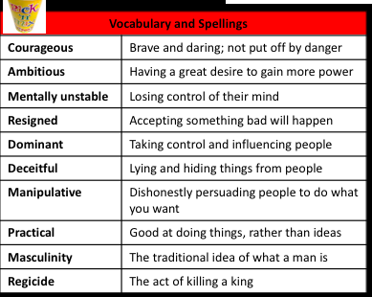
Using the vocabulary on the knowledge organiser, write a short summary paragraph of what happens to each character in the course of the play. Use at least five of the vocabulary words in each summary paragraph. The first one has been done for you.

Macbeth
At the start of the play, we learn that Macbeth is a courageous soldier who has just killed Macdonwald, the enemy chief. However, when he meets the witches he becomes ambitious to be king. His wife persuades him to kill King Duncan when the king comes to visit their castle in Dunsinane. However, once he has committed regicide by killing the king, he becomes more and more mentally unstable, seeing daggers in the air, and hearing noises that aren’t there. In the end, he is a terrible king who murders lots of his people, and he realises by the end that he can’t stop the prophecies coming true, and that his friend Banquo’s children will become kings instead of him. He is resigned to his fate, and eventually he is killed by Macduff, who chops off his head.
Lady Macbeth
___________________________________________________________________________
___________________________________________________________________________
___________________________________________________________________________
___________________________________________________________________________
___________________________________________________________________________
___________________________________________________________________________
___________________________________________________________________________
___________________________________________________________________________
___________________________________________________________________________
___________________________________________________________________________
___________________________________________________________________________
___________________________________________________________________________
The Witches
___________________________________________________________________________
___________________________________________________________________________
___________________________________________________________________________
___________________________________________________________________________
___________________________________________________________________________
___________________________________________________________________________
___________________________________________________________________________
___________________________________________________________________________
___________________________________________________________________________
___________________________________________________________________________
___________________________________________________________________________
___________________________________________________________________________
STUCK?  Write two sentences for each of these characters. Try to use one of the vocabulary words in each sentence. | STRETCH!  Write a short paragraph for each character, about how ambition affects them and those around them.

3) THEMES

‘Themes’ are the big ideas that all books and films explore: things like love, power, and ambition. These are 5 of the main themes explored in Macbeth:

- Fate and free will
- Ambition
- Appearance and reality (this includes lies and deceit)
- Nature and the supernatural
- Guilt and madness

See below for a definition of each of these themes from the Knowledge Organiser

Universal Themes
Fate and free will | Are our lives ruled by God, dark forces, or us?
Ambition | The desire to gain power and importance
Appearance and reality | When all is not what it seems, when people lie to each other and themselves
Nature and the Supernatural | The conflict between the natural order, and evil spirits that try to disrupt it
Guilt and madness | The psychological effects of committing a sin

For each one, make a revision card. This should include:

- A title, showing the theme
- A picture to represent the theme
- Three key things that happen in the play, related to the theme
- Two key quotations from the play (see list of quotations on the Knowledge Organiser)
- A sentence about what Shakespeare is saying about this them in Macbeth

There is an example below:

Theme: Power and ambition | Picture:
Three key things that happen:  1) The witches give Macbeth the idea of being King which makes him ambitious  2) Lady Macbeth wants to kill the king when he visits Dunsinane castle, because she wants to gain power  3) Macbeth murders Banquo’s family to prevent Banquo’s sons from being kings, because he wants to keep the power of being kinh | Two key quotations:  ‘Stars hide your fires / let light not see my black and deep desires’ shows how ambitious Macbeth is  ‘Come you spirits […] unsex me here’ shows Lady Macbeth has the ambition to be a man so she can gain power

4) QUOTATIONS (including online test)
Have a look through the quotations on the knowledge organiser, which are printed below, and the theme revision cards you have made.
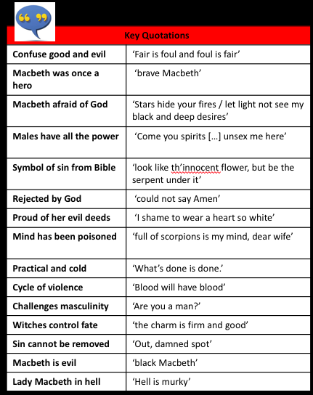

Then choose your top 10 quotations, and write them here:

1.
2.
3.
4.
5.
6.
7.
8.
9.
10.
To test your knowledge of the quotations on the knowledge organiser, go to here and take the quiz: https://quizlet.com/279524747/flashcards Keep going until you can get 15/15!
STUCK?  Stuck? Google ‘Mr Bruff, Mac’s Not Hot. That should help you to choose your top 10, and it might involve Stormzy. | STRETCH!  Use the extension booklet on Show My Homework to make a list of five key quotations for each character.

- CONTEXT
‘Context’ is what was happening at the time something was written. The following things were important influences on the writing of Macbeth:
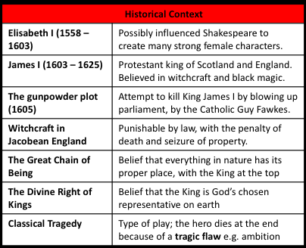
Watch the first 9 minutes of Miss Cole’s context video (go to You Tube and search for ‘Miss Cole Macbeth Context’).

Answer the following questions to make sure that you understand what context is, and how the context of Macbeth affected the choices that Shakespeare made when he wrote this play.

- What does ‘context’ actually mean? List 3 types of context that the video mentions:

-
-
-

- Who was on the throne when Shakespeare’s early plays were written?
_____________________________________________________________________
- What did Shakespeare do to challenge stereotypes of women at the time (most people thought that women were inferior and the possessions of men)?
_____________________________________________________________________
- The next person on the throne was James I. Which famous rebel tried to kill James I? How?
_____________________________________________________________________
- What is regicide?
_____________________________________________________________________
- Why did Shakespeare decided that Macbeth had to die at the end of the play, according to this video?
_____________________________________________________________________
- Which things in the play would appeal to James I’s interest in the supernatural?
_____________________________________________________________________
- What message does the end of the play give the audience about being involved with supernatural forces such as ghosts and witches, according to this video?
_____________________________________________________________________
- What happens in the play show that what Macbeth has done, when he killed the king, was a sin against God?
_____________________________________________________________________
- The Great Chain of Being put Kings next to God in the natural order of the world. How does Macbeth disrupt this natural order?
_____________________________________________________________________
- How does Shakespeare make sure the natural order (the Great Chain of Being) is restored by the end of the play, to please King James I?
_____________________________________________________________________

TEST YOURSELF!
Make a revision card, explaining what each of these things are, and what they have to do with Macbeth. If you can, find a quotation that relates to this and add it to the card.

- James I
- Guy Fawkes
- The supernatural
- Religion
- The Great Chain of Being
STUCK?  Just write one sentence, explaining what each of the five things on the last page has to do with Macbeth. | STRETCH!  Extension: Google ‘Stuart Knott Prezi Macbeth Tragic Hero’. Add how these are relevant to Macbeth.  Relating Macbeth to the ancient tradition of tragic theatre will really impress the examiners!

What can I do next to revise?
- Keep working through the GCSEPod tasks

- Watch the online version at home by searching for ‘Macbeth Great Performances’ on www.vimeo.com and use this booklet and the Knowledge Organiser to explain what is happening to your family!
- Have a rest!

