Homework 5

Due in:

1. What is  59  238  + 1785 | 3. 234 x 6 (show all your working)
2. What is  436  - 78  ____ | 4. Write the number 867 in words
5. 192 ÷ 6 (show your working) | 8. What is 30% of 140
6. What is 75% as a fraction? | 9. Pete buys three pies for £3.35 each and pays with a twenty pound note, how much change does he get?
7. Write $\frac{4}{5}$ as a decimal. | 10. Write $\frac{9}{10}$ as a percentage.

11. Write down the time shown on the clock.  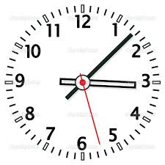 | 14. Write 0.72 as a percentage
12. Write these numbers in order of size, start with the smallest  7, 78, 17, 73, 175 | 15. Write these numbers in order of size, start with the smallest  0.43, 5.3, 3.5, 0.6, 5.28
13. What is the volume of this cuboid? 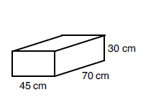 | 16. Work out $\frac{7}{11}+\frac{6}{11}$

17. Here is a list of numbers  2, 3, 5, 12, 27, 36  Write down a multiple of 4 | 19. Here is a list of numbers  2, 3, 5, 12, 27, 36  Write down a factor of 48
18. Here is a list of numbers  2, 3, 5, 12, 27, 36  Write down two numbers that add up to 32. | 20. Write 5.04 correct to 1 decimal place.

Total:

