YEAR 10 HOMEWORK – 5R
BOOKLET 2

Complete the questions in each box. Make sure that you show all of your workings

1. Ken buys some fruit.  He buys apples, bananas, peaches and oranges.  Ken buys  4 apples weighing 155 g each  3 bananas weighing 135 g each  3 peaches weighing 165 g each  Each orange has a weight of 105 g.  The fruit has a total weight of 2.255kg.  Work out how many oranges Ken buys | 2. 40 students were asked how they get to school.  The table shows the results.  Bus Walk Car Bicycle  Number of students 11 7 14 8  Complete a pie chart for the information in the table.
3. Here is a map of an island. Work out the distance between the 2 villages  2.5cm = 12km | 4. A cinema ticket costs £9x The price of a child’s ticket is one half the price of an adult ticket minus £4. Write an expression for the price, in pounds, of a child’s ticket
5. Find the input if the output is 52  -8  X15 | 6. Find the bearing of A from B  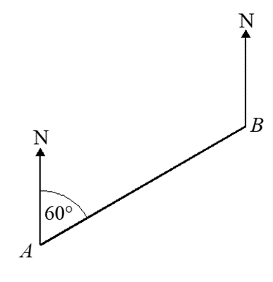  57º
7. Rachel drives 300 miles from London to Newcastle. She drives the first 165 miles at an average speed of 50 mph. From this point it takes Rachel 3 hours and 25 minutes to complete her journey. What was Rachel's average speed for the whole journey? | 8. Expand and simplify  (2x - 3)²
9. Factorise 3x³y + 6x²y² | 10. Simplify 12m⁷y² ÷ 4m³y
11. Write 95 as a product of its prime factors. | 12. Frank is travelling from the USA to Germany. Frank wants to book flights which cost $710 and a hotel which costs €45 per night for 12 nights. The exchange rates are as follows: £1 = €1.14 $1 = €0.85 Frank can spend no more than £1000 Work out if Frank is able to book the flights and the hotel.
13. Write the gradient and y intercept of the line:  2x - 8 = 3y | 14. Mel buys a house for £352 000 She sells the house for £340 200. Calculate the percentage loss Mel makes
15. A rock has a mass of 64 grams and a density of 3.4 grams/cm³ . Work out the volume of the rock. | 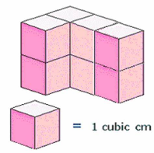  16. Draw the plan and the side elevation for the solid.  Side view
17. Perrie invests £15000 for 2 years in a savings account. She gets 4.5% per annum compound interest. Calculate the total amount of interest Perrie will get after 3 years. | 18. Draw on a number line  5 < x - 2 < 9
19. The ratio of dogs to cats is 6:1 The ratio of fish to dogs is 3:1 Find the ratio of cats to fish. | 20. Make x the subject of the formula

WWW

EBI

EBI

