YEAR 10 HOMEWORK – WEEK1

1.Find the perimeter:  5cm  5cm  2cm  1cm  3cm  2cm  3cm  5cm | 2. Find the Area using area = πr²  10cm  ( π= 3.14 )
3. Find the volume:  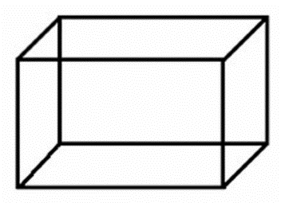  3m  5m  8m | 4. Simplify:  6k + 9k

5. Simplify 12X x 2 | 6. Simplify 12X ÷ 3
7. Write an expression for the perimeter  f  2f  2f | 8. Expand the bracket and simplify:  3(f + 2)
9. Fill in the blank in the equation:  8p + ____ = 4(2p + 3 ) | 10. Find the value of P when x = 2 and y = 3:  P = x + 2y

11. Find the probability of a purple ball being pulled out if these are the probabilities of the other colours  Blue 0.1 Green 0.2  Red 0.3 Purple = | 12. Complete the two-way table.  Shaded Unshaded  Circles 1  Triangles 1  Total 2 3
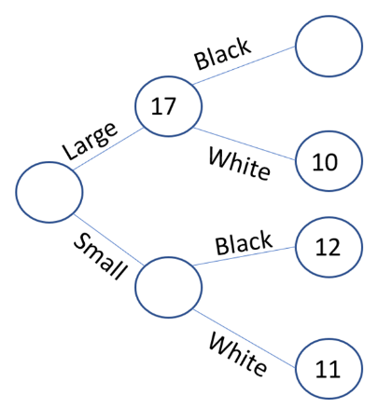  13. Fill in the blank circles  40 | 14. In a card game Jayne wins 4 out of 10 games. Estimate how many games she would win out of 20.
15. In form 9H 14 students are studying Maths, 8 students are studying French, 6 are studying both  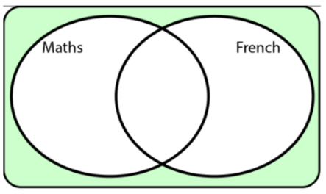  Complete the Venn diagram: | 16. Complete the inequality shown on the number line  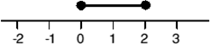  0 ≤ X ≤ ______
17. Write the following numbers in ascending order.  2.24, 2.5, 2.04 |  | 18. Round 24 to the nearest 10
19. Write in its simplest form  10  6 |  | 20. Write the fractions in ascending order:  $\frac{1}{8}$ $\frac{5}{8}$ $\frac{3}{8}$

